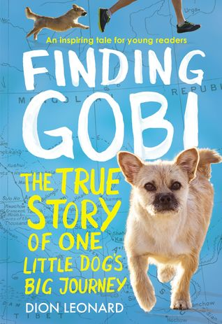 | Finding Gobi The True Story of One Little Dog’s Big Journey | Dion Leonard | Broomfield  j636.7 Leona  audio jCD Leona | Anythink  J Pets Dogs | Hunter’s Glen  92 Leo
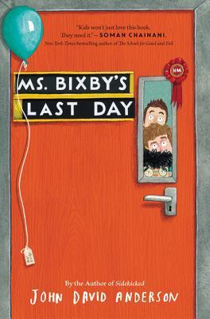 | Ms. Bixby’s Last Day | John David Anderson | Jpb Ander  JCD Ander  E audio  E book overdrive | JF Anderson  Audio e-book (hoopla) | AND
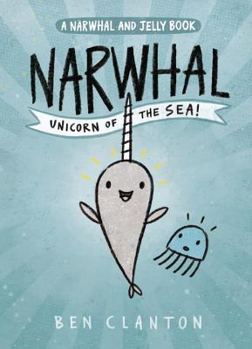 | Narwhal: Unicorn of the Sea | Ben  Clayton | Graphic | J Graphic Narwhal | CLA
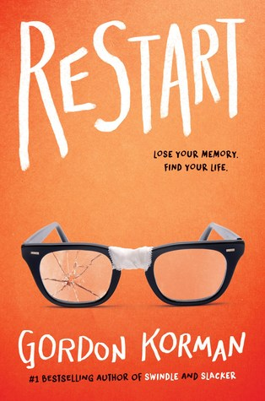 | Restart | Gordon Korman | J Korma  Audio CD  e-book | JF Korman | KOR
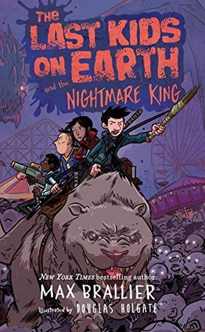 | Last Kids on Earth and the Nighmare King  Book 3 | Max Brallier & Dennis Holgate | JBrall  e-book | JF Brallier | BRA
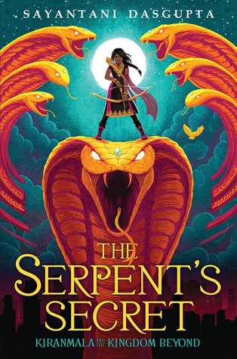 | The Serpent’s Secret: Kiranmala and the Kingdom Beyond Book 1 | Sayantani Dasgupta | J DasGu  e-book  audio CD  e-audio book | JF Fantasy Dasgupta  Audo CD  E book  E audio  playaway | DAS
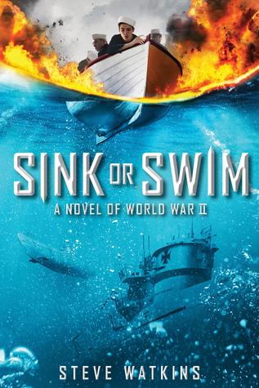 | Sink or Swim: A Novel of World War II | Steve Walkins | J Watk | JF History Watkins | WAT
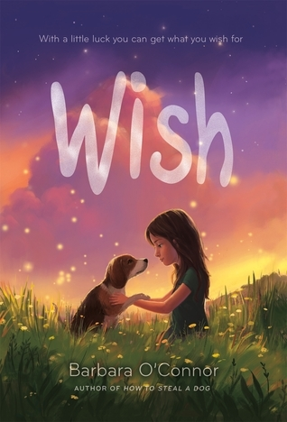 | Wish | Barbara O’Connor | e-book  J OCONN  Audio CD | JF O’Connor | WAT  e-book
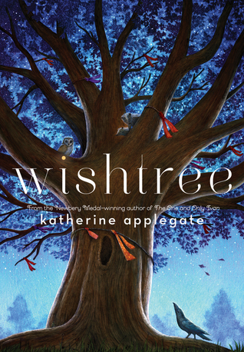 | Wishtree | Katherine Applegate | J Apple  e-book  audio CD  audio overdrive | JF Fantasy Applegate  Audio CD  E book  E audio  playaway | APP
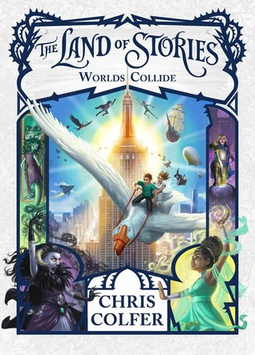 | Land of Stories 6: World’s Collide | Chris Colfer | Col-Lan 6  Audio CD  Overdrive | JF Fantasy Colfer  Audio CD  E book  E audio  playaway | http://thelandofstories.com/news/2017/7/5/the-land-of-stories-official-party-kit

