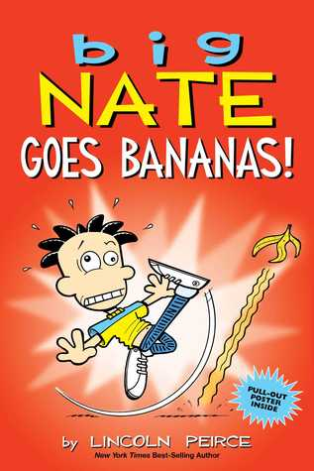 | Big Nate Goes Bananas Lincoln Peirce  This collection of comic strips has Nate ready for summer vacation which can't come soon enough! No school, baseball, beach trips, and blech! yellow bananas? Everyone at P.S. 38 is a little stir-crazy as the school year winds down. RL 2.5 Lexile 360L
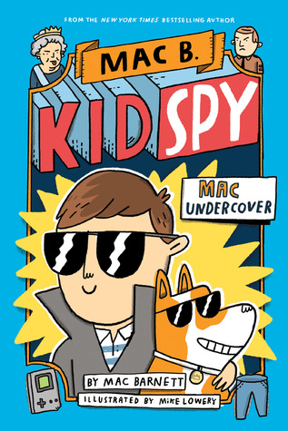 | Mac B. Kid Spy: Mac Undercover, Mac Barnett  This first book in the humorous series by Mac Barnett has him receive a telephone call from the Queen of England, recruiting him to find the crown jewels (well, actually just the Coronation Spoon) and so Mac embarks on his first adventure as a secret agent--with the assurance that the Queen will give him a note excusing him from school. RL-5.0 Lexile 460L
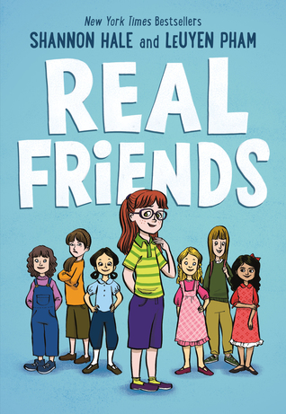 | Real Friends Shannon Hale and Luyen Pham  This graphic novel memoir by Shannon Hale is illustrated by Luyen Pham. When her best friend Adrienne starts hanging out with the most popular girl in class, Shannon questions whether she and Adrienne will stay friends and if she is part of the clique.  RL Level 3.7 Lexile 290L
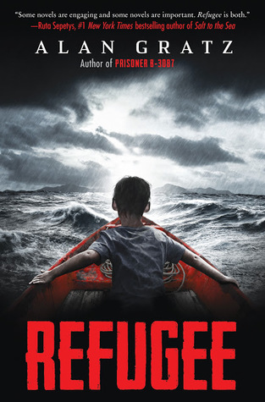 | Refugee Alan Gratz. Josef is a Jewish boy living in 1930s Nazi Germany. With The threat of concentration camps looming, he and his family board a ship bound for the other side of the world. . . Isabel is a Cuban girl in 1994. With riots and unrest plaguing her country, she and her family set out on a raft, hoping to find safety in America. . . Mahmoud is a Syrian boy in 2015. With his homeland torn apart by violence and destruction, he and his family begin a long trek toward Europe . . . All three kids go on harrowing journeys in search of refuge. RL Level 5.3 Lexile 800L
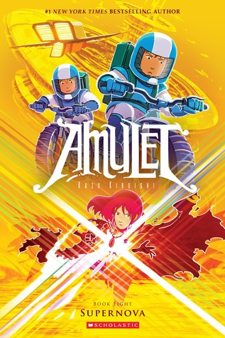 | Supernova (Amulet #8) Kazu Kibuishi  When Emily loses control of her Amulet, she is imprisoned in the Void, where she must escape the influence of the Voice,while her brother, Navio travels to a space station where the Resistance is preparing to battle the approaching Shadow forces. RL 2.7 Lexile 330L
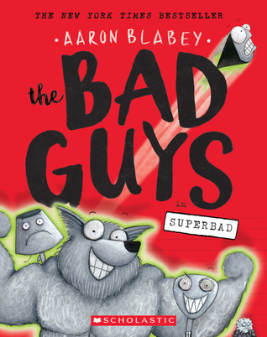 | Bad Guys *8: Superbad Aaron Blabey. The 8th book in this graphic series the Bad Guys working with the defective super powers have a chance to save the world from Marmalade. Book 8 introduces The International League of Heroes containing 5 female counterparts to Bad Guys. As in the first book this can provide a format for student writing activities. RL 2.7, Lexile 530L
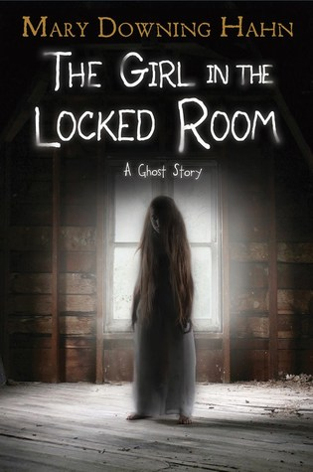 | The Girl in the Locked Room, Mary Downing Hahn  This short novel is told in two voices, Jules, whose father is restoring an abandoned house in present day, and a girl who lived in the house a century earlier. As the characters begin to communicate, the mystery is revealed. RL 4.1 Lexile 650L
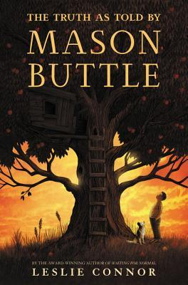 | The Truth as Told By Mason Buttle Leslie Connor  Mason is the Biggest and sweatiest kid in his grade. His learning disabilities are compounded by the grief he suffered when his best friend died last year. This schoolyear finds him making a new friend and getting suppor from his fantastic teacher his new firend Calvin Chumsky. RL 5.0 Lexile 310L
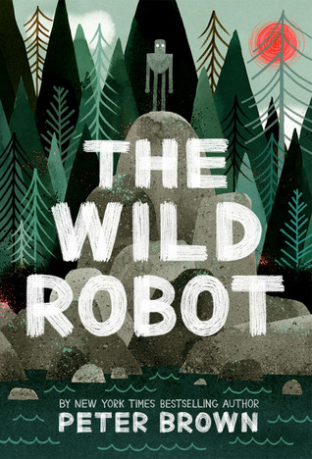 | The Wild Robot Peter Brown  When robot Roz is stranded on a remote island survival depends on befriending and in essence adopting some of the wildlife there.  RL Level 5.8 Lexile 740L
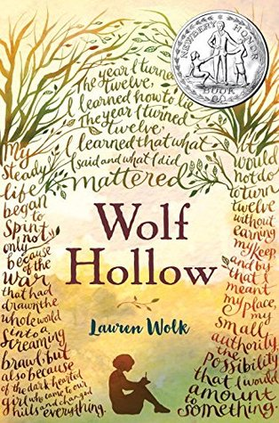 | Wolf Hollow Lauren Wolk  This Newbery Honor book is set in small family farm and town in Pennsylvania in the 40's. Annabelle suffers bullying from a new student, Betty Glengarry. A mystery ensues where Annabelle has to defend Toby, a shell-shocked World War I soldier living in the woods.  RL- 4.9 Lexile 800L

