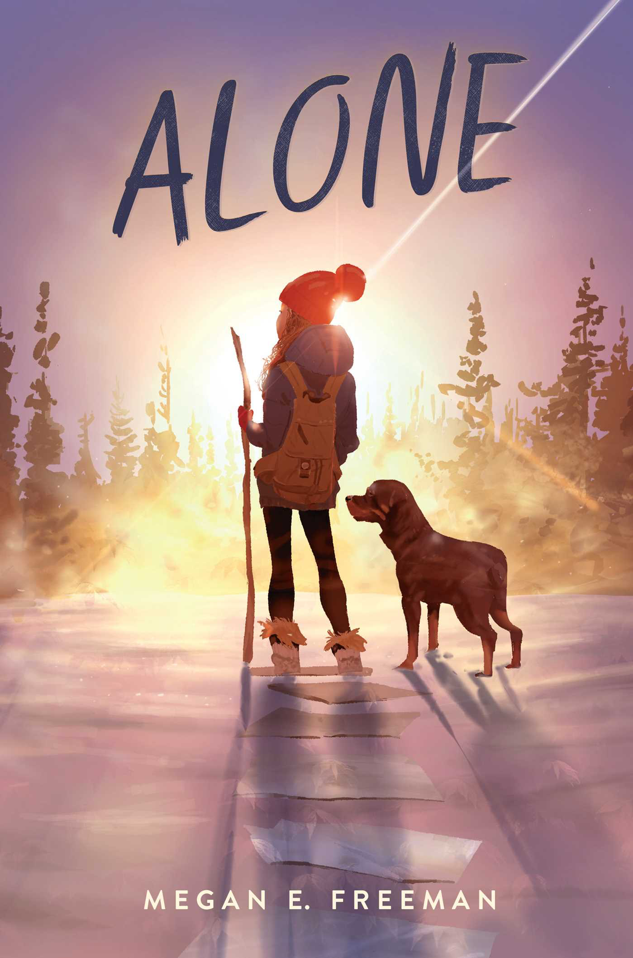 | https://www.simonandschuster.com/books/Alone/Megan-E-Freeman/9781534467569 | Alone RL 4.7 690LWhen twelve-year-old Maddie hatches a scheme for a secret sleepover with her two best friends, she ends up waking up to a nightmare. She's alone--left behind in a Colorado town that has been mysteriously evacuated.
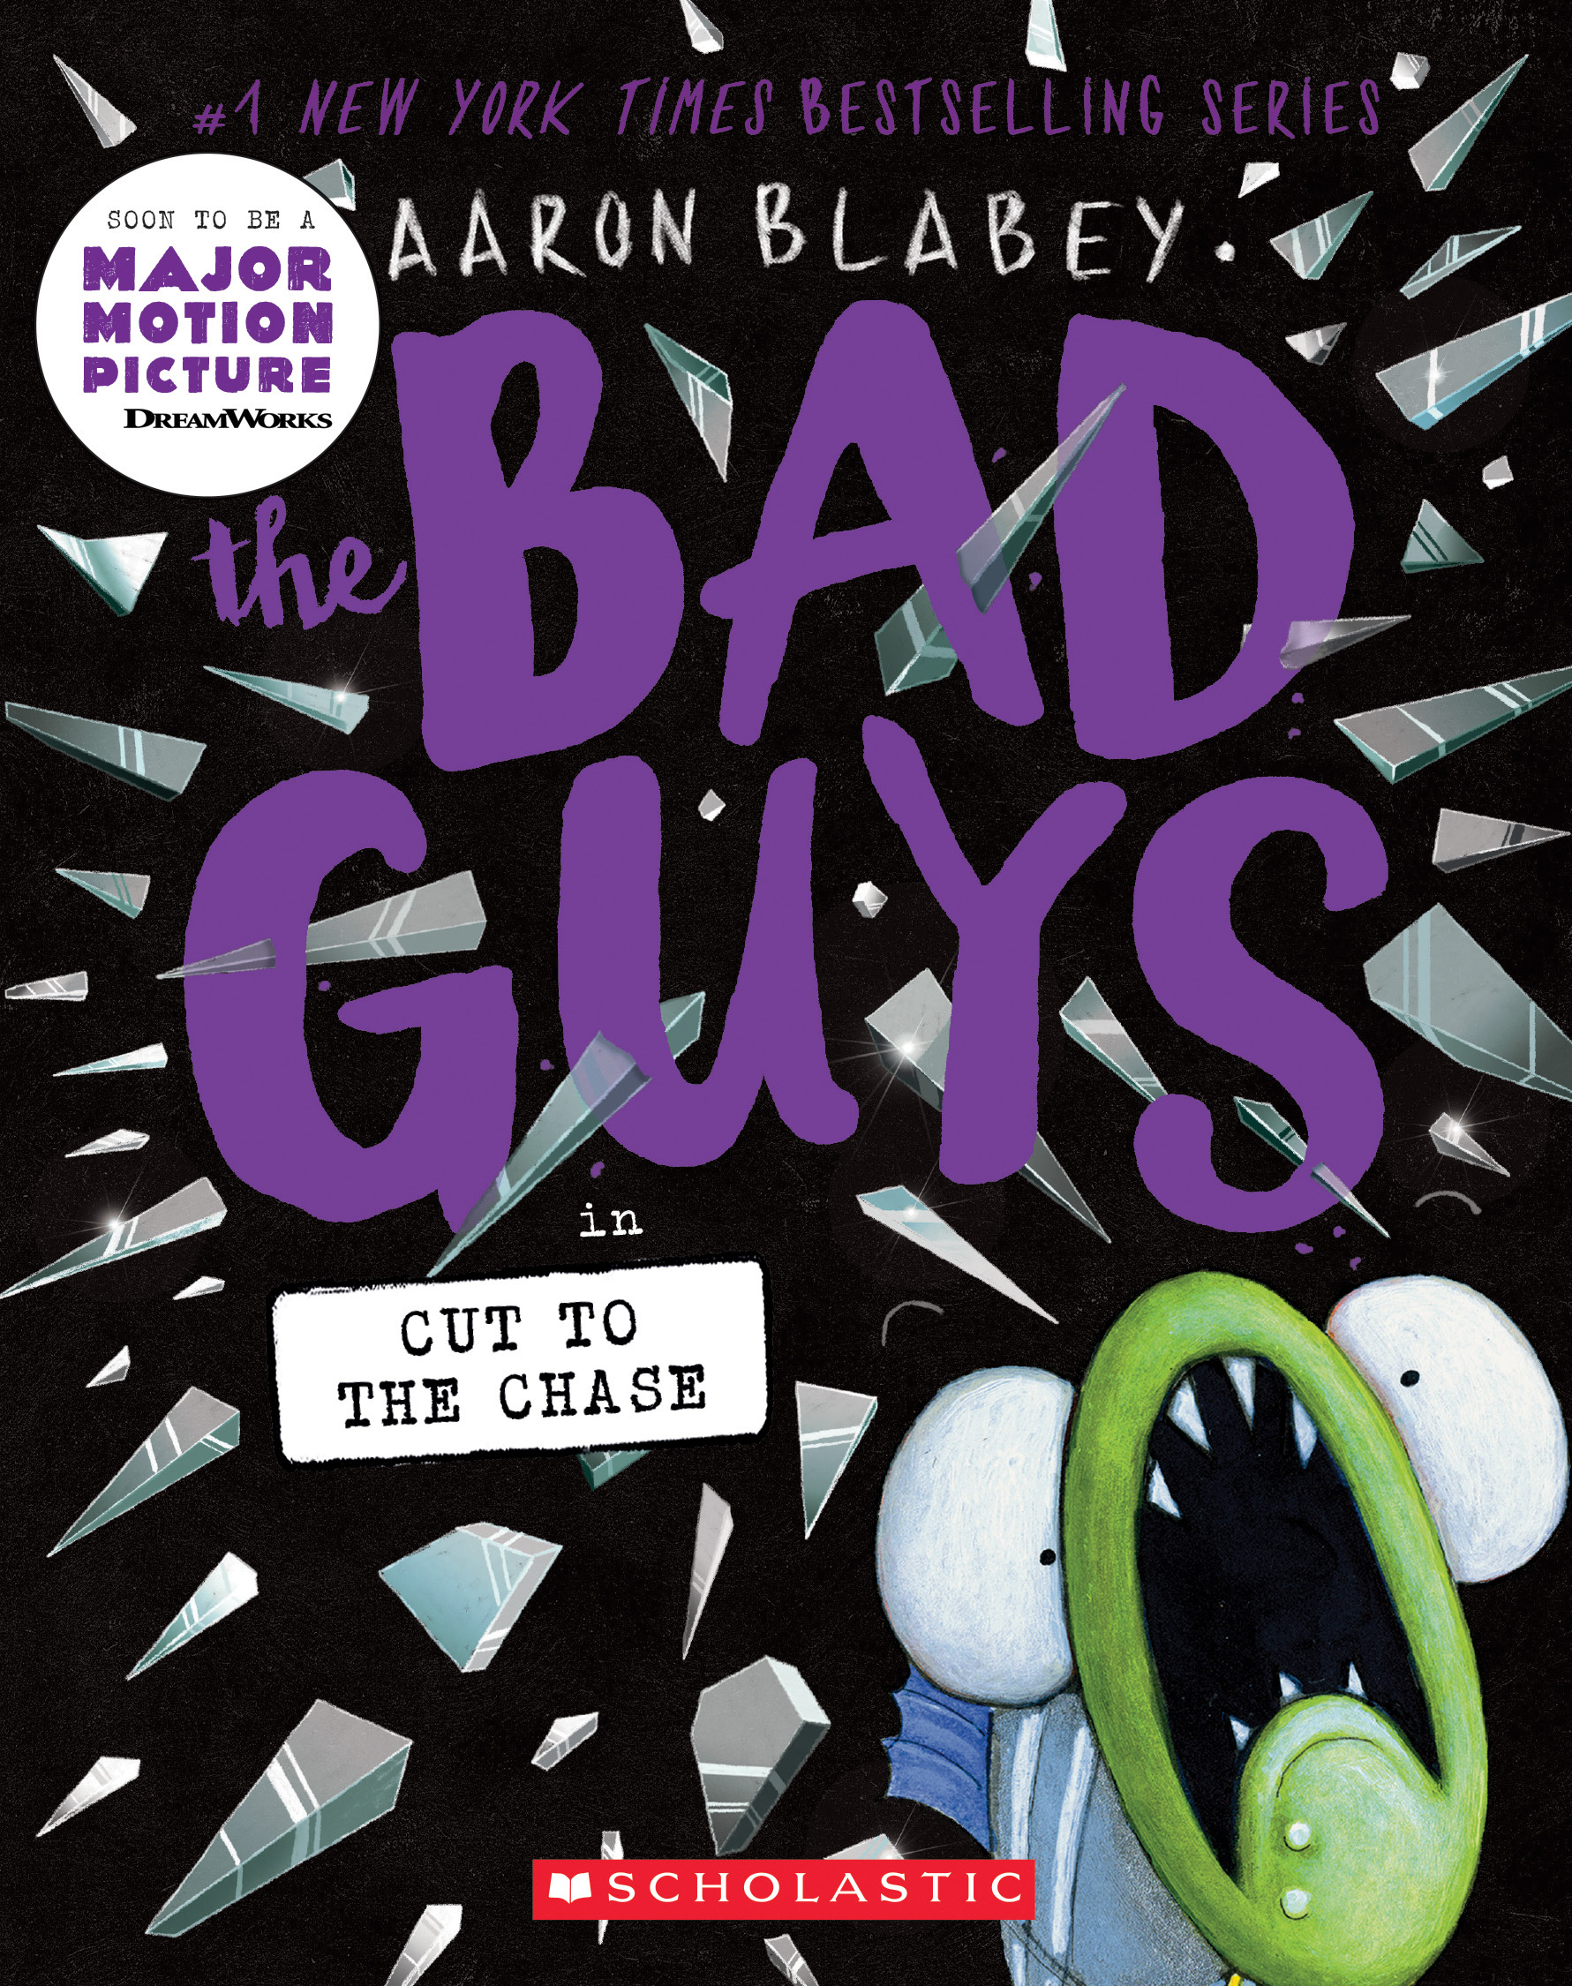 | https://www.pdfread.net/ebook/the-bad-guys-in-cut-to-the-chase-aaron-blabey/  https://www.youtube.com/watch?v=fvlC_8S7b90 | Bad Guys # Cut to the Chase – 2.4RL, Movie not yet out when nominated- full 198 pg. graphic novel.
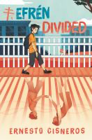 | https://www.youtube.com/watch?v=Ejx4O4mdHag  https://www.youtube.com/watch?v=JM0_wzeYabI | Efren Divided , RL 4.7. 710L  "While his father works two jobs, seventh-grader Efrén Nava must take care of his twin siblings, kindergartners Max and Mia, after their mother is deported to Mexico. Includes glossary of Spanish words”
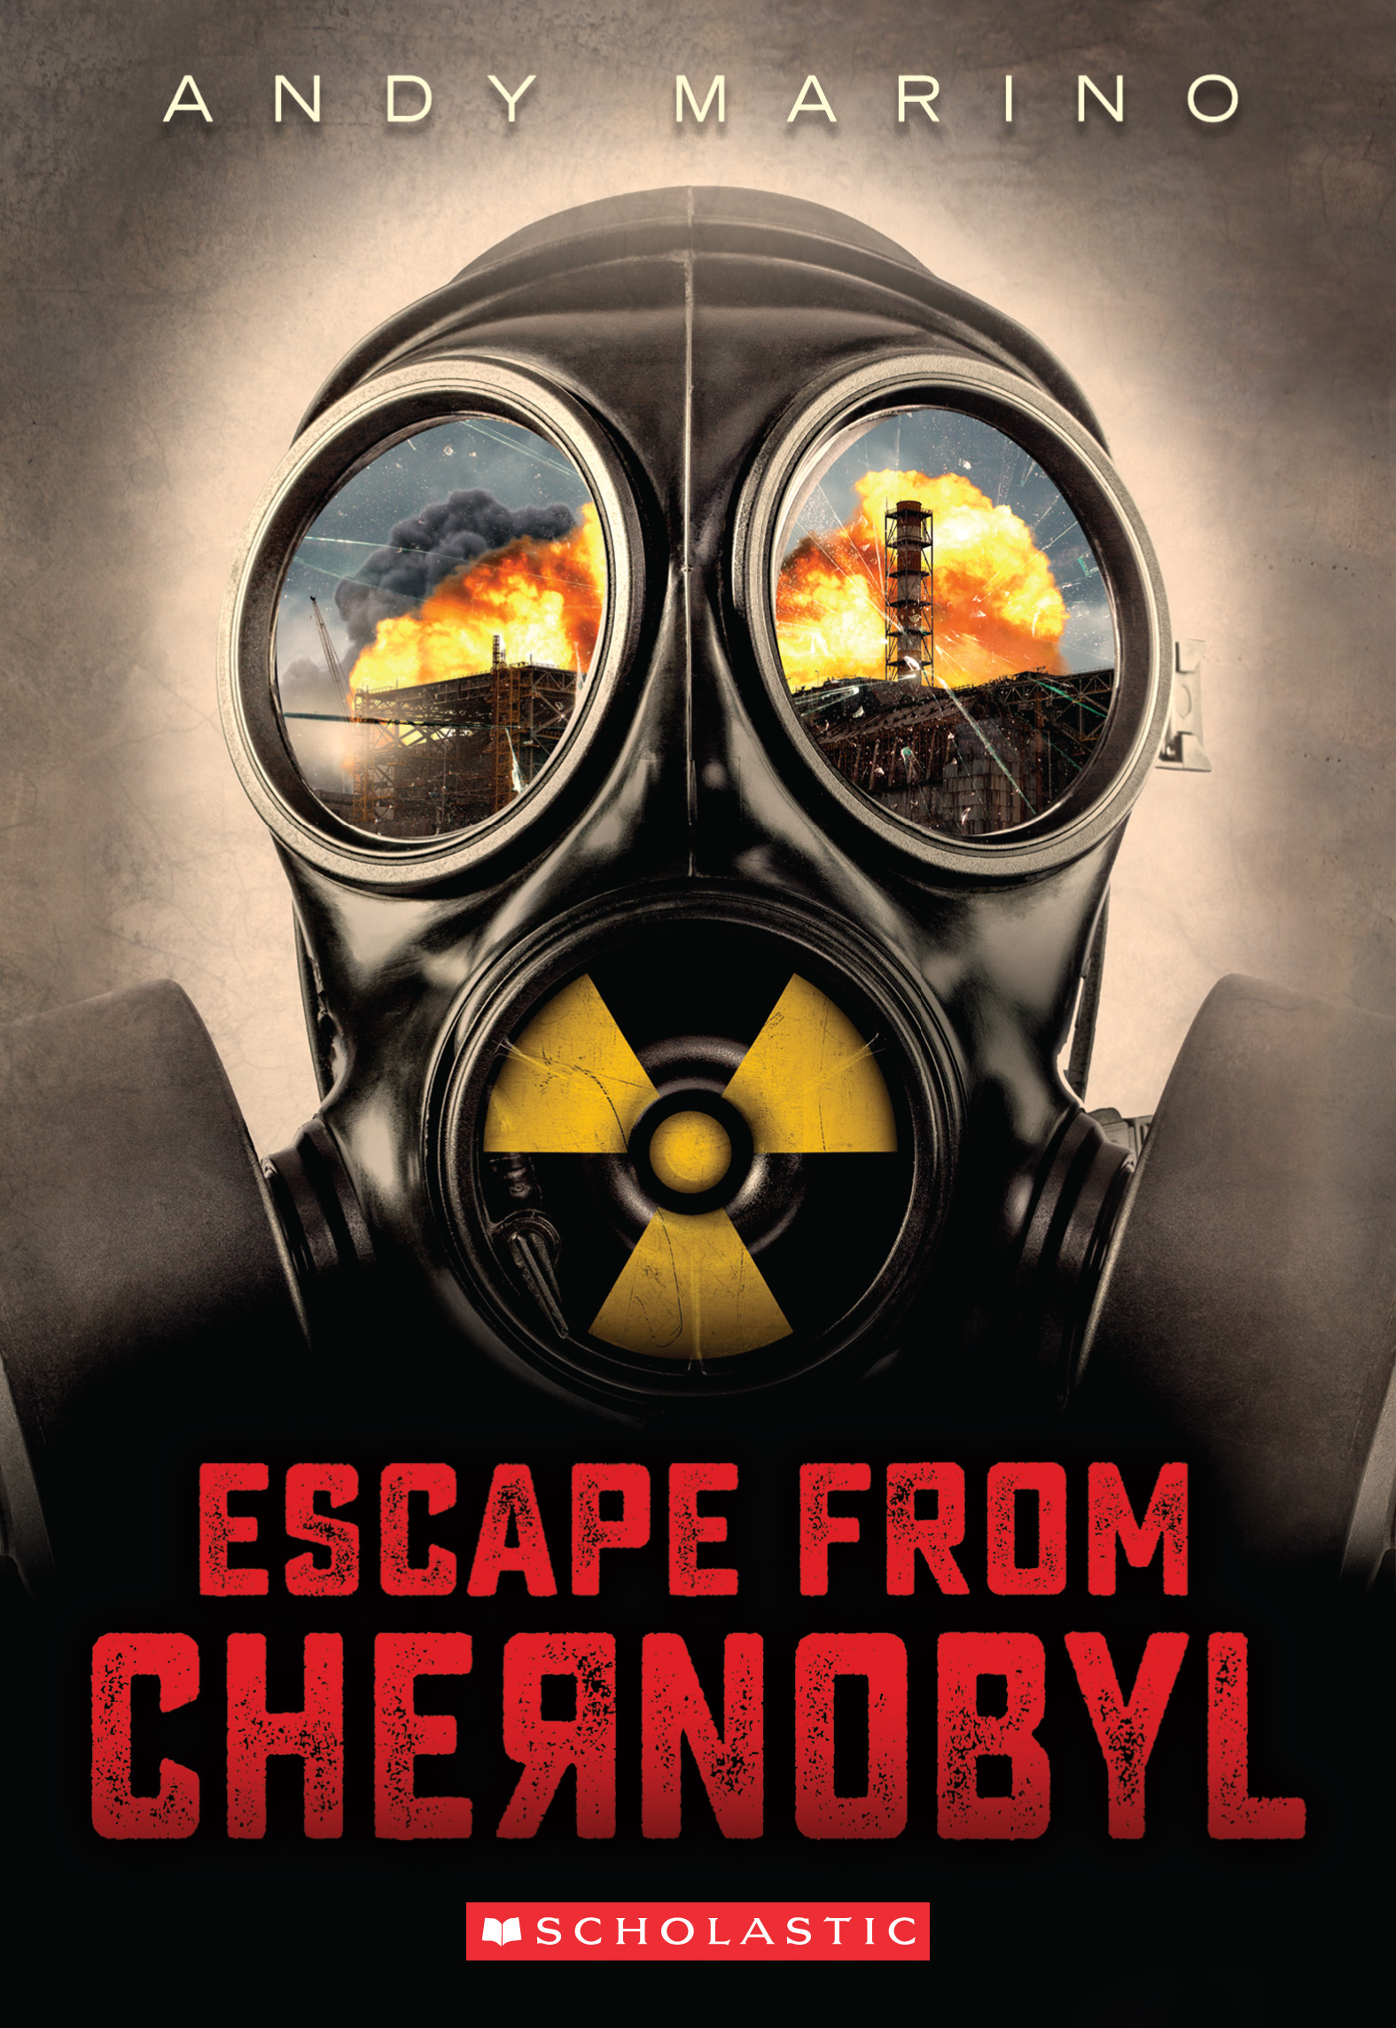 | http://www.andy-marino.com/  https://www.youtube.com/watch?v=txfDI3X-9UI | Escape from Chernobyl – RL5.6, MG+ Two young siblings flee the Chernobyl disaster with their parents, but the Communist party is on their heels.
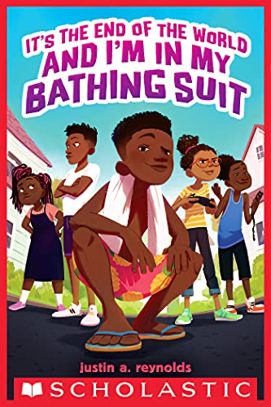 | https://www.youtube.com/watch?v=Ze4nlQWxgXs  https://www.youtube.com/watch?v=hfGTOthh4kQ | It’s the End of the World and I’m in my Bathing Suit – 5.6 RL When the electricity goes out, twelve-year-old Eddie and his friends set out to investigate what is going on when they make the startling discovery that they are the only ones left in their neighborhood--and perhaps anywhere.
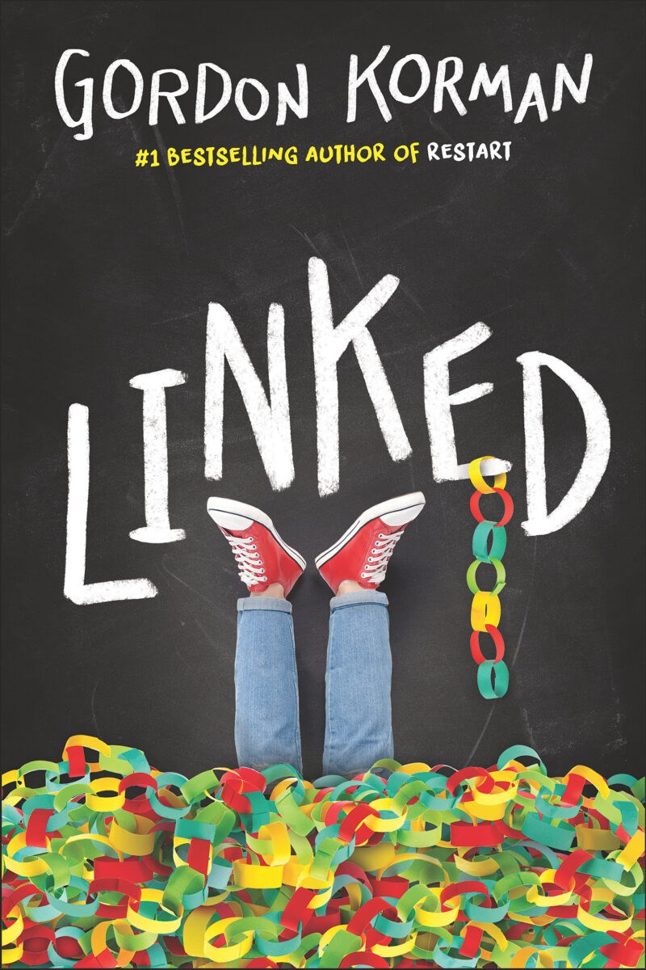 | https://gordonkorman.com/linked | Linked RL5.3, 750L  Link, Michael, and Dana live in a quiet Colorado town and confront issues when a swastika shows up on the school gym wall.
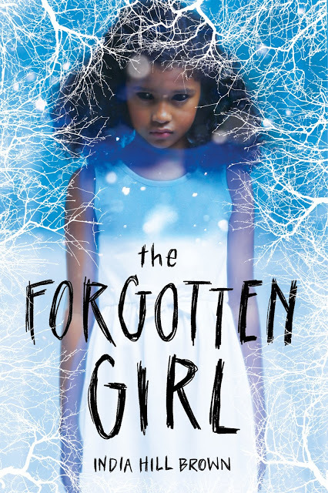 | https://www.facebook.com/watch/?v=732313143879081  https://www.youtube.com/watch?v=PTpaEbOal-M | Forgotten Girl, RL 4.7, 670L – Daniel and Iris while investigating the local graveyards discover the neglected and forgotten Black cemetery and disturb a Avery, a jealous and demanding ghost.
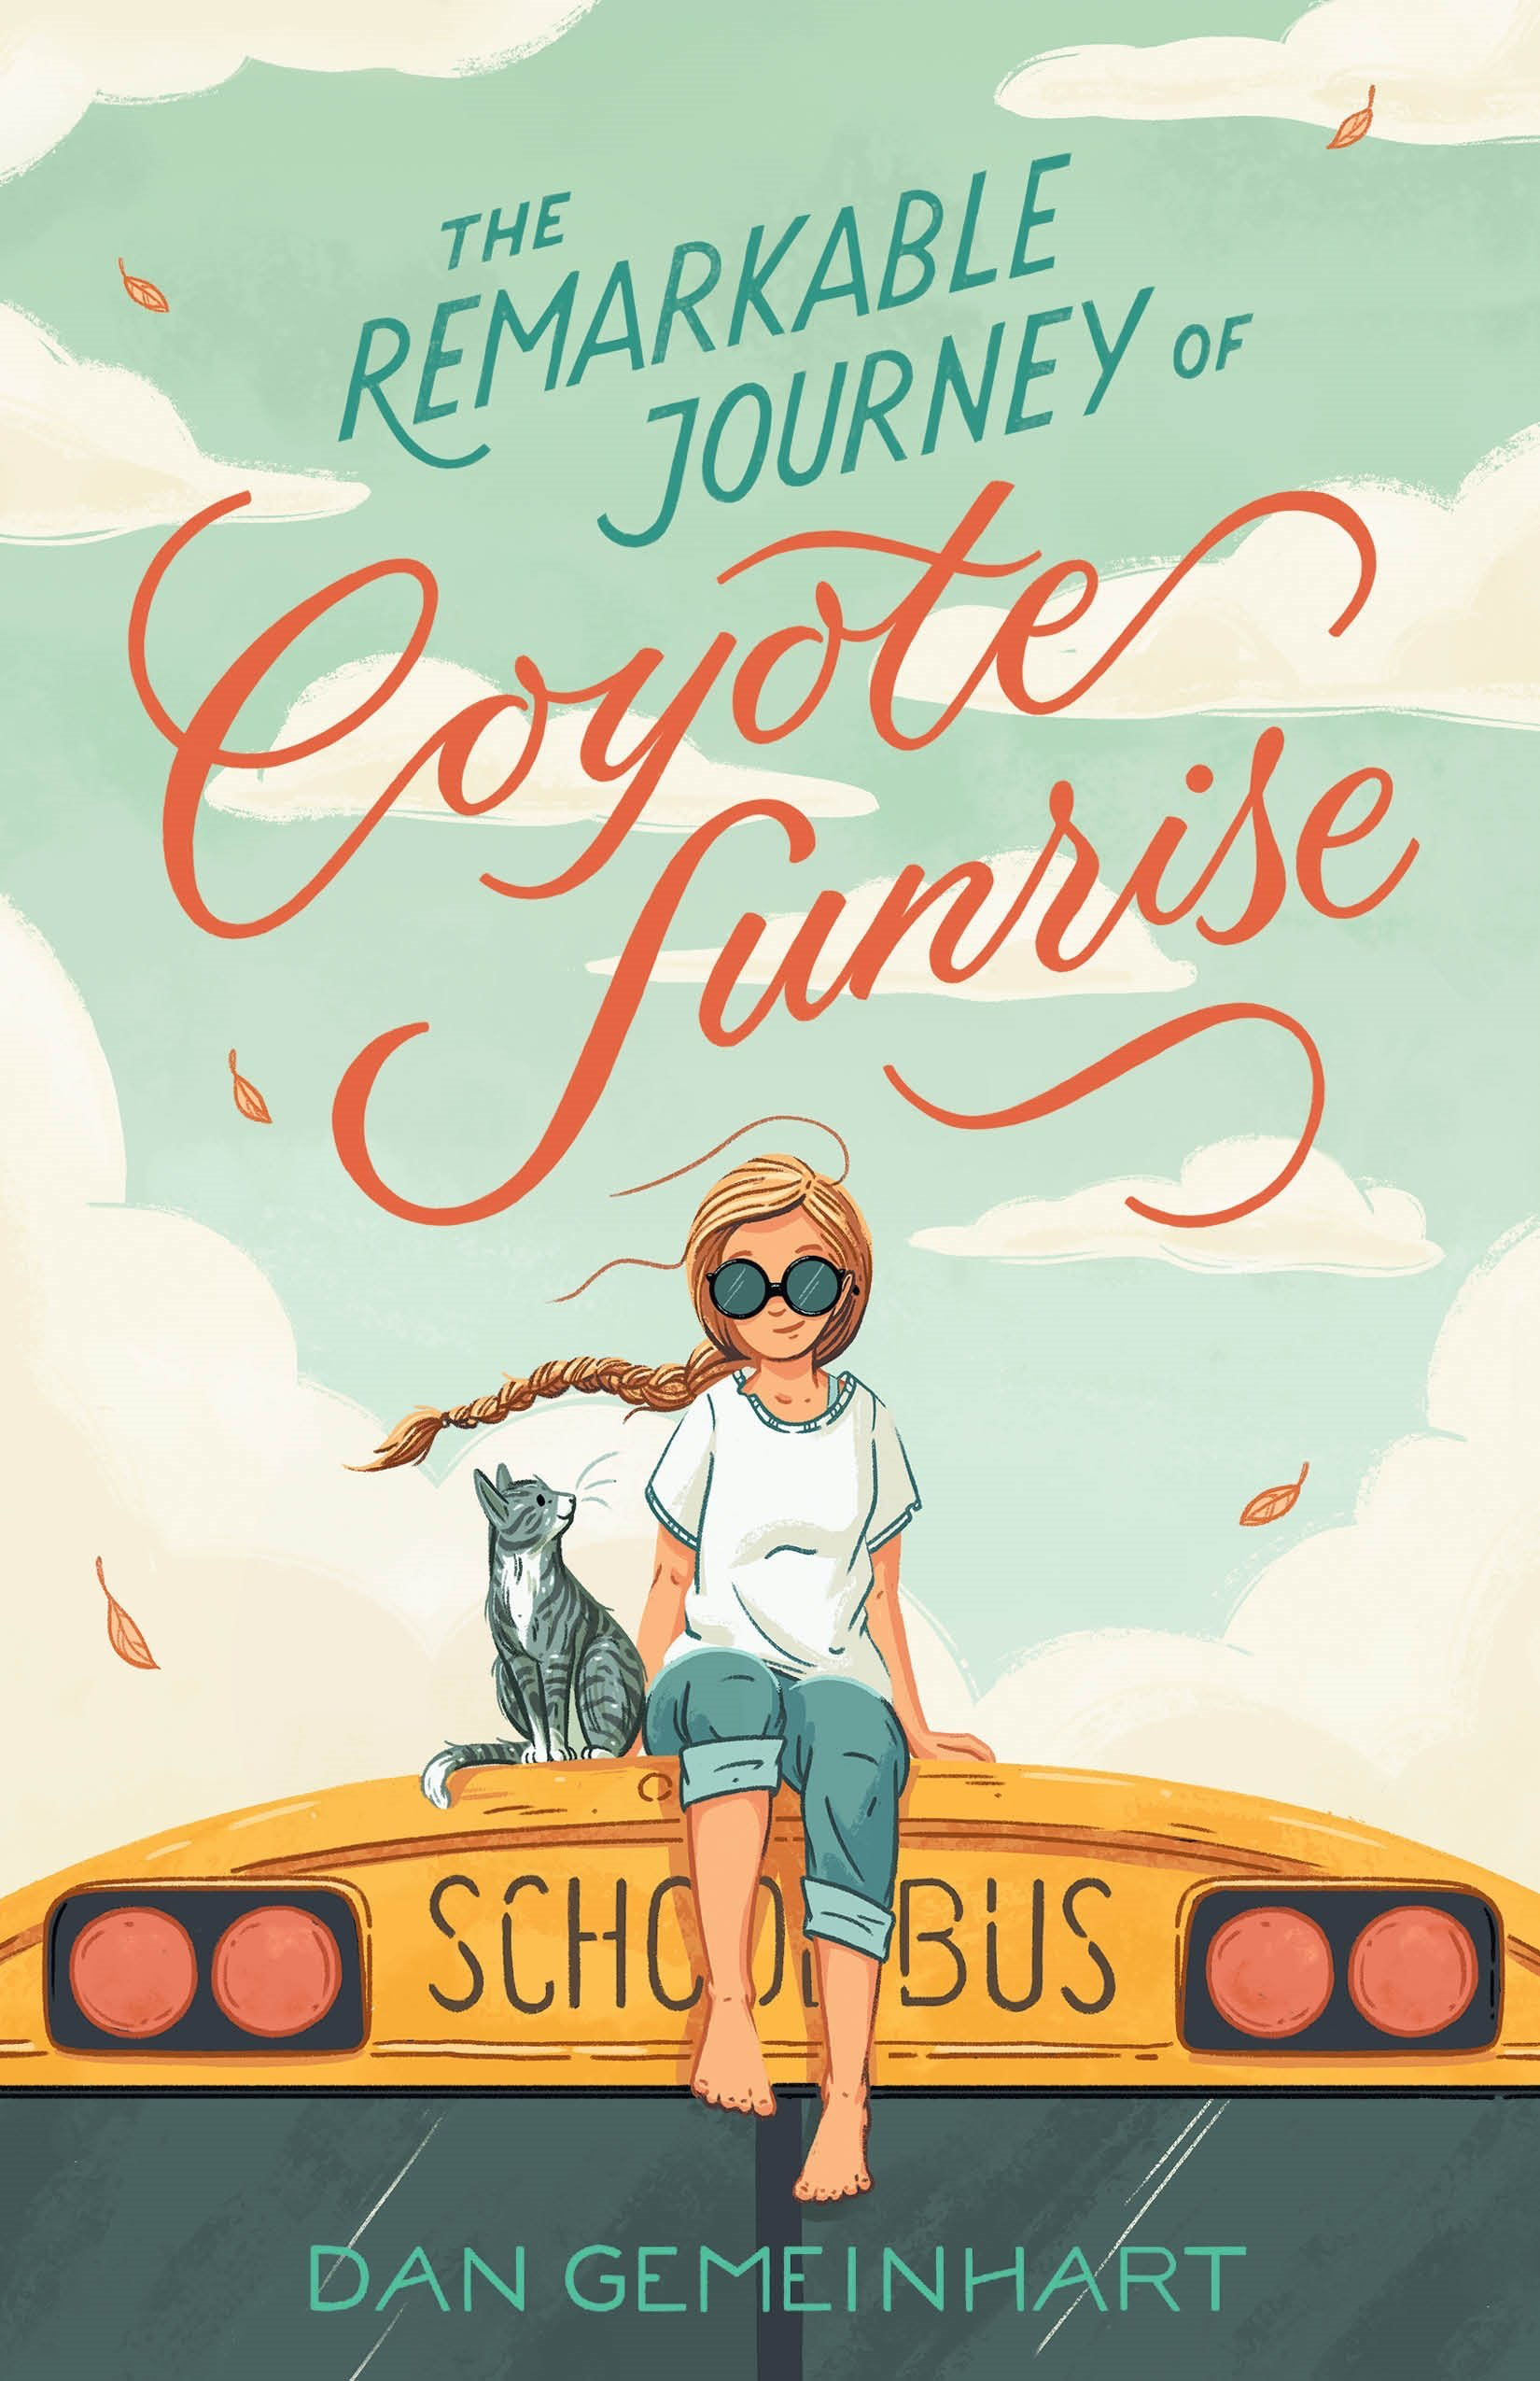 | https://us.macmillan.com/books/9781250196705/theremarkablejourneyofcoyotesunrise | Coyote Sunrise, RL 4.7, 730L, Twelve-year-old Coyote and her father rush to Poplin Springs, Washington, in their old school bus to save a memory box buried in a park that will soon be demolished.
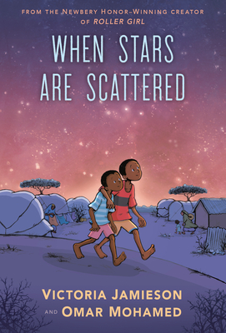 | https://www.youtube.com/watch?v=111ztD-2QaU  https://www.penguinrandomhouse.com/books/599538/when-stars-are-scattered-by-victoria-jamieson-and-omar-mohamed-illustrated-by-victoria-jamieson-color-by-iman-geddy/ | When Stars are Scattered 3.7RL, 530L Graphic Novel  remarkable graphic novel is about growing up in a refugee camp, as told by a former Somali refugee to the Newbery Honor-winning creator of Roller Girl.’
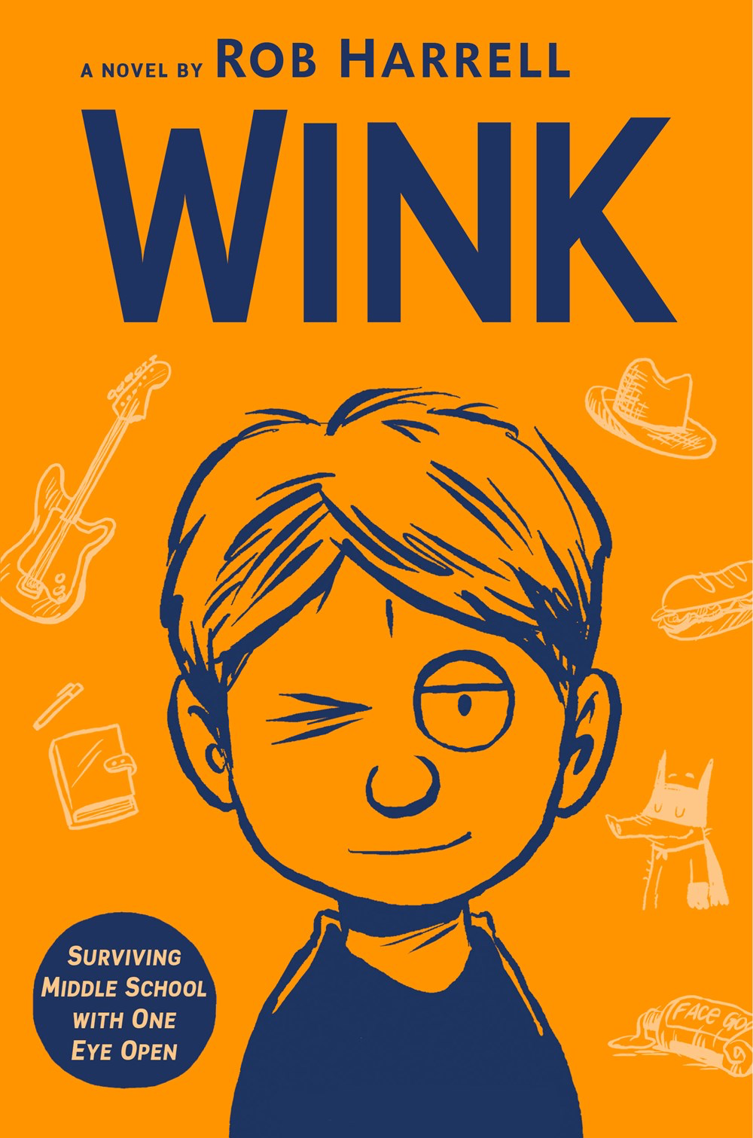 | https://www.youtube.com/watch?v=OVr7d5DAtbs | Wink, RL3.9 580L, 3*, Fictionalized memoir of twelve-year-old Ross is diagnosed with a rare form of eye cancer, he just wants all to be normal.

