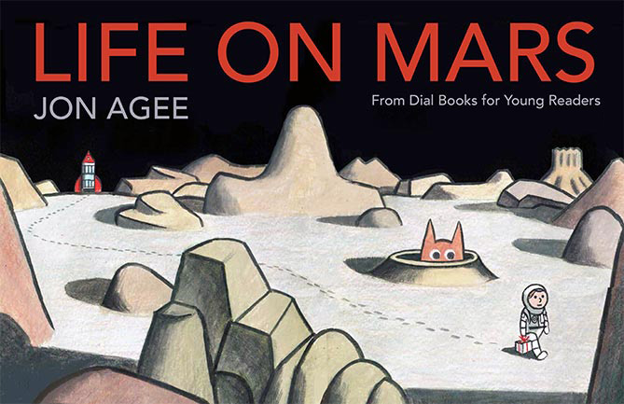
Palendrome – words or phrases that read exactly the same forward and backward. (Madam, I’m Adam)
Spoonerism - Flip-floping the initial sounds of words. (Save the Whales, Wave the Sails)
Oxymoron – words or phrases that contradicts itself, they have opposite meanings. (Jumbo shrimp)

Palendrome – words or phrases that read exactly the same forward and backward. (Madam, I’m Adam)
Spoonerism - Flip-floping the initial sounds of words. (Save the Whales, Wave the Sails)
Oxymoron – words or phrases that contradicts itself, they have opposite meanings. (Jumbo shrimp)

Palendrome – words or phrases that read exactly the same forward and backward. (Madam, I’m Adam)
Spoonerism - Flip-floping the initial sounds of words. (Save the Whales, Wave the Sails)
Oxymoron – words or phrases that contradicts itself, they have opposite meanings. (Jumbo shrimp)

Palendrome – words or phrases that read exactly the same forward and backward. (Madam, I’m Adam)
Spoonerism - Flip-floping the initial sounds of words. (Save the Whales, Wave the Sails)
Oxymoron – words or phrases that contradicts itself, they have opposite meanings. (Jumbo shrimp)

Palendrome – words or phrases that read exactly the same forward and backward. (Madam, I’m Adam)
Spoonerism - Flip-floping the initial sounds of words. (Save the Whales, Wave the Sails)
Oxymoron – words or phrases that contradicts itself, they have opposite meanings. (Jumbo shrimp)

