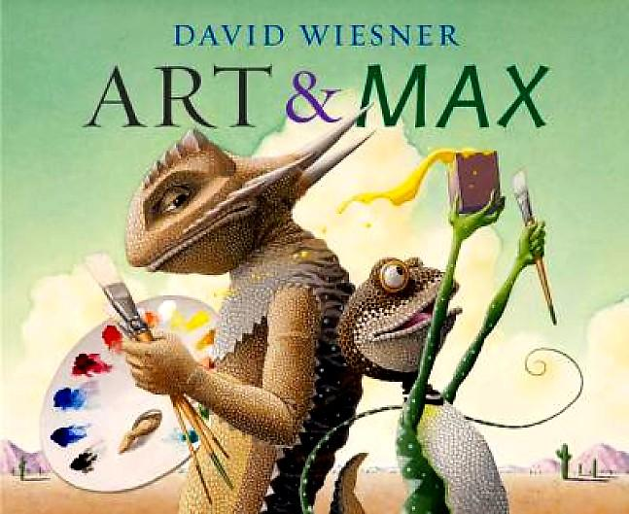
http://www.hmhbooks.com/wiesner/coloringbook.html
Coloring book for Wiesner, David (2010) Art & Max

http://www.hmhbooks.com/wiesner/coloringbook.html
Coloring book for Wiesner, David (2010) Art & Max

http://www.hmhbooks.com/wiesner/coloringbook.html
Coloring book for Wiesner, David (2010) Art & Max

http://www.hmhbooks.com/wiesner/coloringbook.html
Coloring book for Wiesner, David (2010) Art & Max

http://www.hmhbooks.com/wiesner/coloringbook.html
Coloring book for Wiesner, David (2010) Art & Max

http://www.hmhbooks.com/wiesner/coloringbook.html
Coloring book for Wiesner, David (2010) Art & Max

