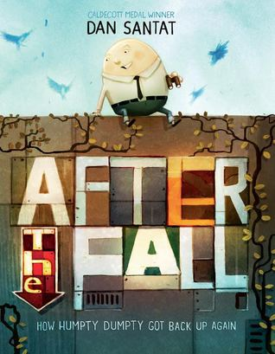 | https://www.youtube.com/watch?time_continue=12&v=Ue2jS4wUBVs | After the Fall Trailer in YouTube 1 min.
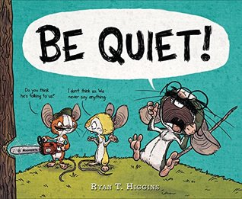 | https://www.youtube.com/watch?v=BBsHYhYQV50 | 5 minute Colby Sharp Interview Ryan T. Higgins (for teachers)
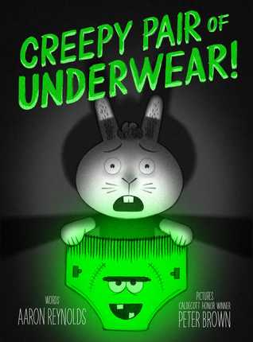 | https://www.youtube.com/watch?time_continue=2&v=Npl7Ps9bbFE | One minute trailer by Penguin on YouTube
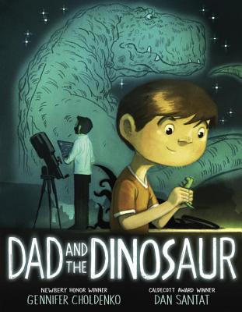 | https://www.youtube.com/watch?v=JPLCVYJP0EA | 2 min. Trailer for Dad and the Dinosaur by Penguin
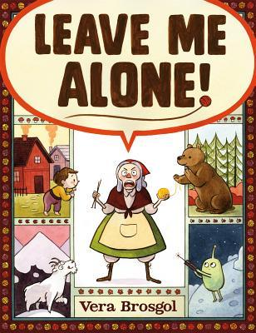 | https://www.youtube.com/watch?v=Trd2w9Khk_0 | 4 min. read aloud of Leave Me Alone by Lee RebelTech
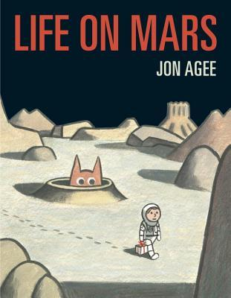 | https://www.youtube.com/watch?time_continue=2&v=Npl7Ps9bbFE | One minute trailer by Penguin on YouTube
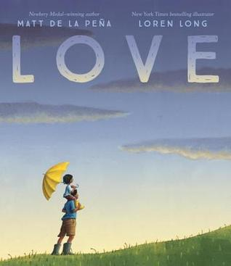 | https://www.youtube.com/watch?v=fFuNhwAI8oE&t=3s&ref=PRH4F05051EDB12&linkid=PRH4F05051EDB12&cdi=2444D92EF91C38EBE0534FD66B0A92C3&template_id=8048&aid=randohouseinc49093-20 | 4 min interview/trailer from Penguin on YouTube  http://time.com/5093669/why-we-shouldnt-shield-children-from-darkness/
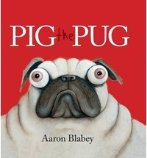 | https://www.youtube.com/watch?v=eXOCBQnPSwQ  https://www.youtube.com/watch?v=YVOZXaTgBic | One Min. Pig the pug trailer by Scholastic Bookfair  3 minute Aaron Blabey Read Aloud by Schalastic on YouTube
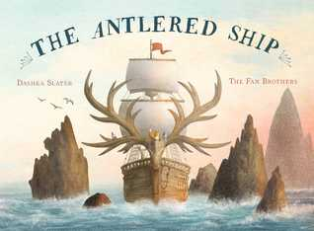 | https://www.youtube.com/watch?v=xUIQxO5Is0E | Six minute YouTube with Dashka Sleaker "How to Make An Antlered Ship"
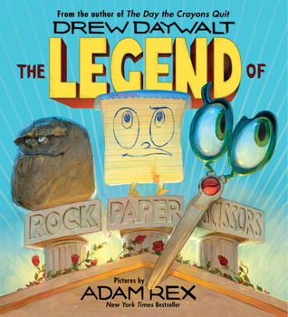 | https://www.youtube.com/watch?v=kjvc6fGF9II | One min. Legend of Rock Paper Scissors Trailer by HarperKids on YouTube

