 | Tarver | Anythink | Broomfield | Hunter’s Glen
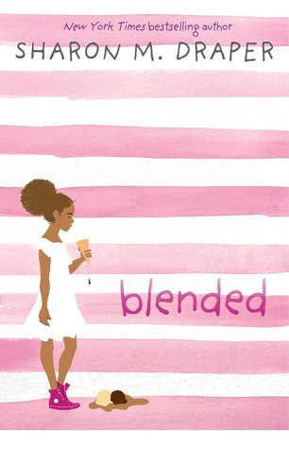 | Ebook  Large Print | E book  JF Draper  Audio E Book | J Drape  JCD  Ebook  Audio ebook | DRA  ebook
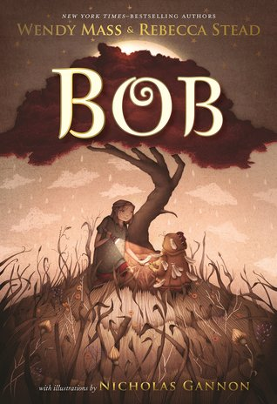 | MAS | J F Fantasy Mass  E book | J Mass  JCD  Overdrive ebook | MAS
 | GRA | Historical J F History Gratz | Playaway  Audio ebook  ebook | GRA
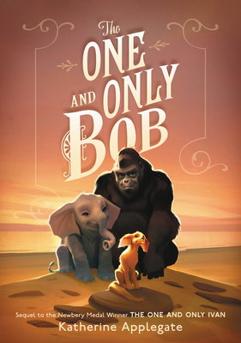 | APP | Playaway  Audio CD  Ebook  Audio ebook | Playaway  Audio ebook  Ebook  overdrive | APP
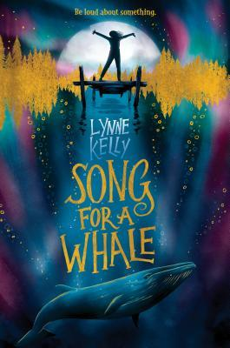 | KEL  Ebook | Book  E audio book  E book | Book  Audio CD  Overdrive eAudiobook | KEL  ebook
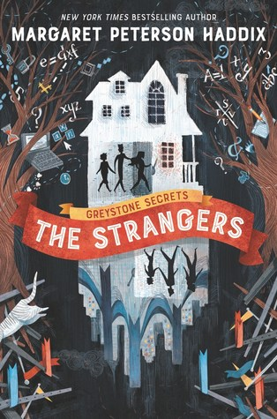 | HAD | Playaway  E book | Playaway  Book  Audio CD | HAD
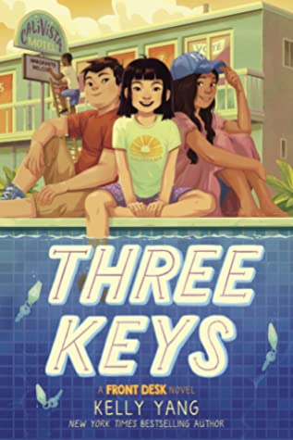 | YAN  ebook | E book  Playaway  Audio CD | Playaway  Book  Overdrive ebook & eAudiobook | E book
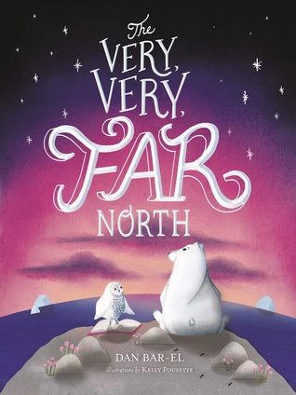 | BAR | Chapter books – general  J F Bar-el | book | BAR
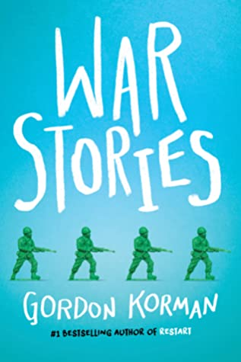 | KOR | Chapter books – general  J Fic Korman | book  E book  Audio Ebook | KOR
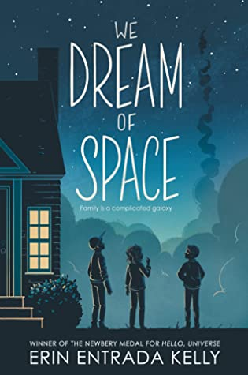 | E book  KEL | Book  E Audio Book  E book | Playaway  Book  Audio e book  E book | KEL  E book

