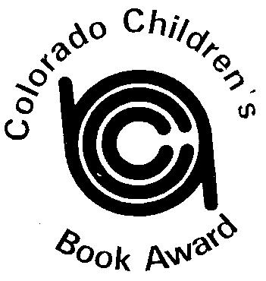
COLORADO CHILDREN’S BOOK AWARD

Sponsored by CCCIRA: Informing, Inspiring and Innovating Literacy in Colorado

2019 Picture Book Winner
The Legend of Rock Paper Scissors
by Drew Daywalt and Adam Rex
2019 Picture Book Runner-Up
Creepy Pair of Underwear
By Aaron Reynolds and Peter Brown
2019 Junior Book Winner
Narwhal: Unicorn of the Sea (Narwhal and Jelly Series)
by Ben Clanton
2019 Junior Book Runner-Up
Restart
by Gordon Korman

