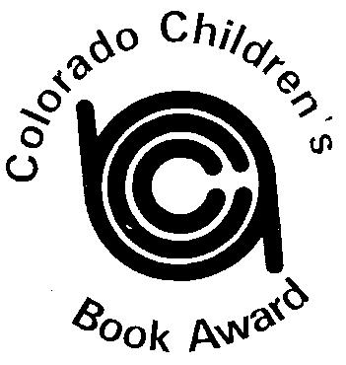
COLORADO CHILDREN’S BOOK AWARD

Sponsored by CCIRA: Informing, Inspiring and Innovating Literacy in Colorado

2020 Picture Book Winner
Can I Be Your Dog?
by Troy Cummings
2020 Picture Book Runner-Up
Bob, Not Bob!
By Liz Garton Scanlon & Audrey Vernick, pictures by Matthew Cordell
2020 Junior Book Winner
The Wild Robot
by Peter Brown
2020 Junior Book Runner-Up
The Girl in the Locked Room
by Mary Downing Hahn

