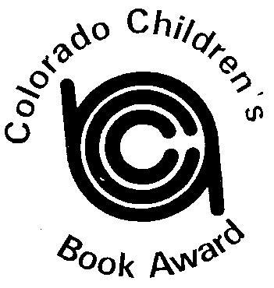
COLORADO CHILDREN’S BOOK AWARD

Sponsored by CCIRA: Informing, Inspiring and Innovating Literacy in Colorado

2021 Picture Book Winner
Llama Destroys the World
by Jonathan Stutzman, illustrated by Heather Fox
2021 Picture Book Runner-Up
The Way Home for Wolf
By Rachel Bright, illustrations by Jim Field
2021 Junior Book Winner
Guts
by Raina Telgemeier
2021 Junior Book Runner-Up
Wildfire
by Rodman Philbrick

