Children’s Choice Book Award Fifth Grade to Sixth Grade Book of the Year 2008- 2018

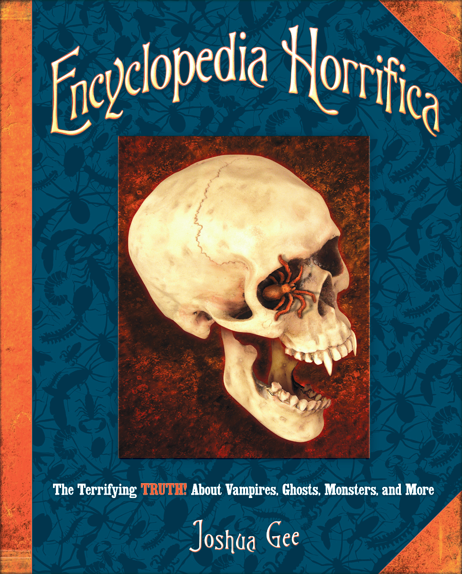2008 Encyclopedia Horrifica by Joshua Gee
Vampires, ghosts, monsters, and more–ENCYCLOPEDIA HORRIFICA invites you to join our quest for the terrifying truth about all things ghoulish and ghastly. But beware! Surprises lurk at the turn of every page. Discover a time line of ALIEN LIFE on earth–beginning 4 billion years ago! Meet a man recruited by the U.S. government to become a PSYCHIC SUPERSPY. Spend a dark and stormy night with professional GHOSTBUSTERS. Visit a mysterious library in search of DRACULA’s shocking origins. Witness new photos of the actual sea monster that inspired the mythical KRAKEN. And much more!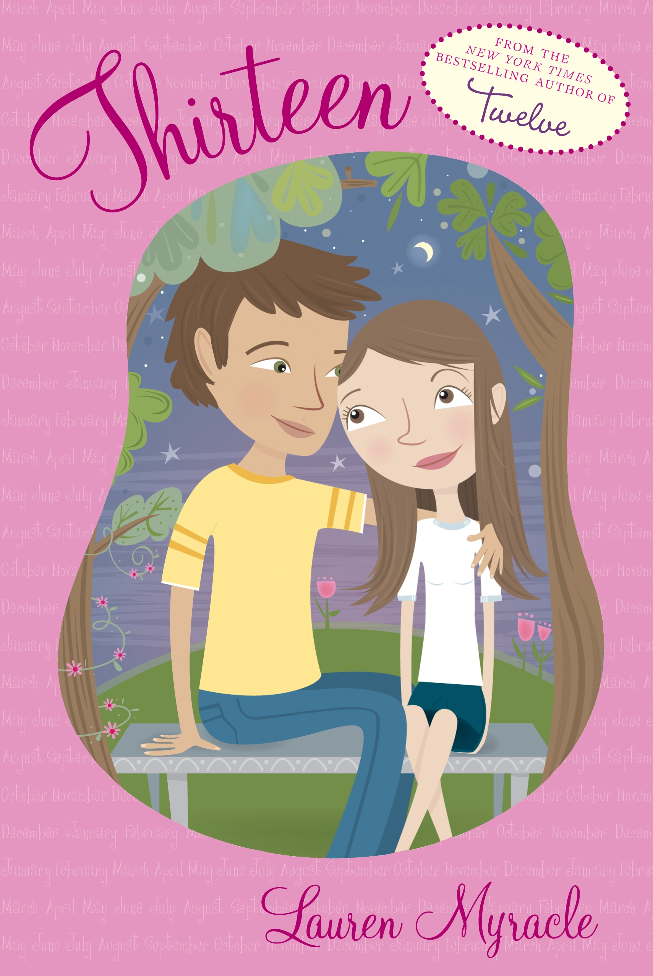2009 Thirteen by Lauren Myracle
Winnie Perry is a teenager—at last! And it’s a really big deal. A ginormous deal, which, wouldn’t you know it, brings ginormous problems along with it. Winnie’s bff #1 is growing up too slowly, while her bff #2 is growing up too fast, leaving Winnie stuck in the middle. Winnie’s boyfriend, Lars, is fabulous—except when he’s not. And as for Winnie’s family, well, BIG changes are in the air.
Bestselling author Lauren Myracle concludes her enormously popular trilogy about a winning young heroine whose humor, daring, and compassion for others is infectious and unforgettable.

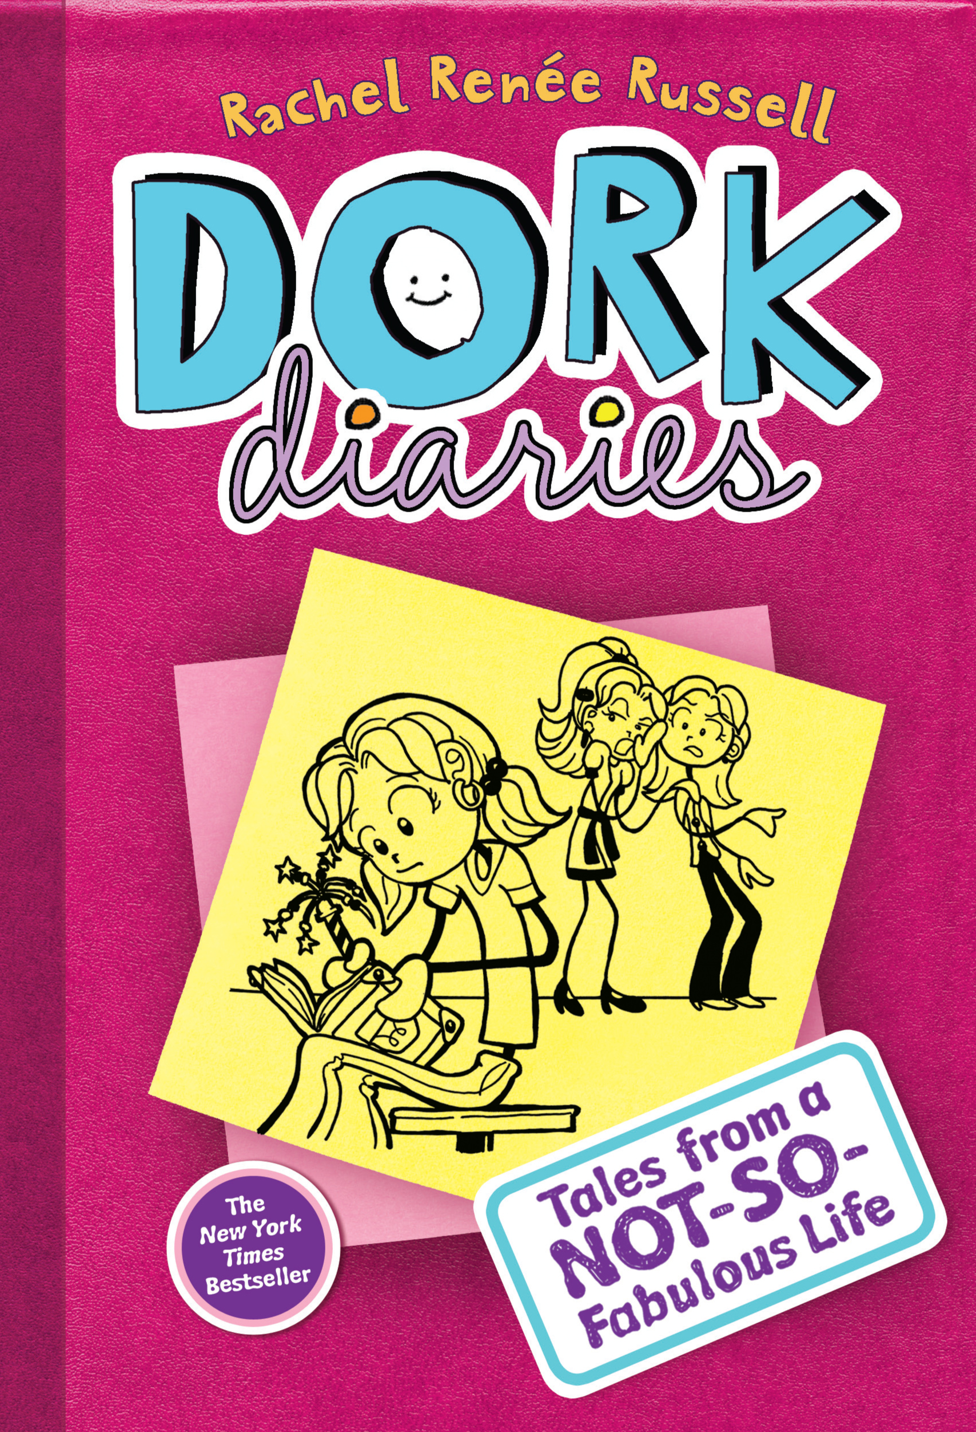 2010 Dork Diaries 1Tales from a Not-So-Fabulous Life
(Book #1 of Dork Diaries) By Rachel Renée Russell
Meet Nikki Maxwell! She’s starting eighth grade at a new school—and her very first diary packed with hilarious stories and art in this SUPER SQUEE updated edition of Book One of the #1 New York Times bestselling Dork Diaries series!
Nikki confesses all in her first diary ever: her epic battle with her mom for an iPhone, meeting her new soon-to-be BFFs Chloe and Zoey, falling for adorably sweet crush Brandon, dealing with her zany little sister Brianna’s antics—and the immediate clashes with mean girl Mackenzie, who becomes Nikki’s rival in a schoolwide art competition.
Nearly 30 million books in print worldwide!

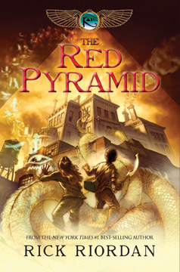2011 The Red Pyramid (The Kane Chronicles, Book 1) by Rick Riordan
Since their mother’s death, Carter and Sadie have become near strangers. While Sadie has lived with her grandparents in London, her brother has traveled the world with their father, the brilliant Egyptologist, Dr. Julius Kane.
One night, Dr. Kane brings the siblings together for a “research experiment” at the British Museum, where he hopes to set things right for his family. Instead, he unleashes the Egyptian god Set, who banishes him to oblivion and forces the children to flee for their lives.
Soon, Sadie and Carter discover that the gods of Egypt are waking, and the worst of them–Set has his sights on the Kanes. To stop him, the siblings embark on a dangerous journey across the globe — a quest that brings them ever closer to the truth about their family, and and their links to a secret order that has existed since the time of the pharaohs.

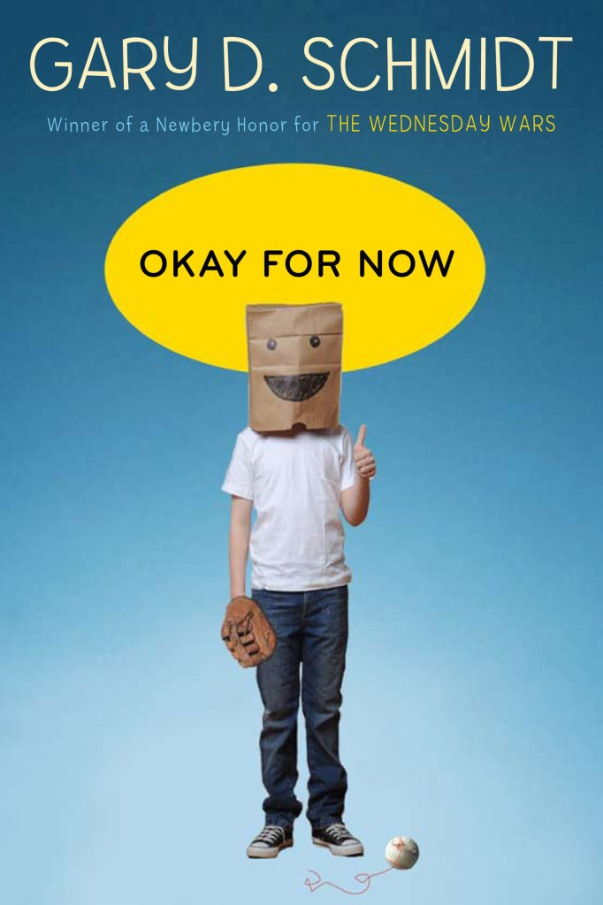 2012 Okay For Now by Gary D. Schmidt

As a fourteen-year-old who just moved to a new town, with no friends and a louse for an older brother, Doug Swieteck has all the stats stacked against him. So begins a coming-of-age masterwork full of equal parts comedy and tragedy from Newbery Honor winner Gary D. Schmidt. As Doug struggles to be more than the “skinny thug” that his teachers and the police think him to be, he finds an unlikely ally in Lil Spicer—a fiery young lady who smelled like daisies would smell if they were growing in a big field under a clearing sky after a rain. In Lil, Doug finds the strength to endure an abusive father, the suspicions of a whole town, and the return of his oldest brother, forever scarred, from Vietnam. Together, they find a safe haven in the local library, inspiration in learning about the plates of John James Audubon’s birds, and a hilarious adventure on a Broadway stage. In this stunning novel, Schmidt expertly weaves multiple themes of loss and recovery in a story teeming with distinctive, unusual characters and invaluable lessons about love, creativity, and survival.

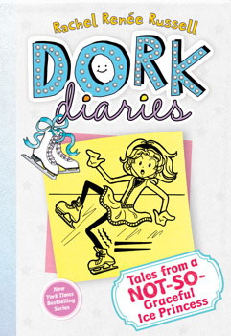 2013 Dork Diaries 4: Tales from a Not-So-Graceful Ice Princess
In an all-new addition to the New York Timesbestselling series that’s as popular as it is dorky, Nikki Maxwell is determined to help out her crush!
Nikki Maxwell isn’t at all surprised to find out that her crush Brandon volunteers at a local animal shelter. He’s such a sweet guy—of course he wants to help those adorable puppies! Then Brandon tells her that the shelter is in danger of closing, and Nikki knows she can’t let that happen. Especially when she discovers a shocking secret about Brandon that makes keeping that shelter open more important than ever. So Nikki and her friends Chloe and Zoey enter an ice skating competition to help raise money for the shelter, but (big surprise) Mackenzie has to stick her nose in and cause trouble so that she can be the one to swoop in and save the day. No way will Nikki let that happen: She’ll just have to come up with some extra creative ideas this time!

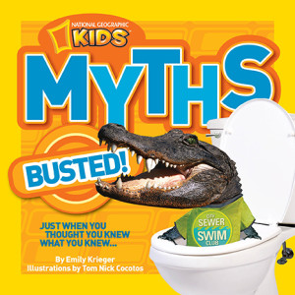 2014 National Geographic Kids: Myth Busted by Emily Krieger

Did you know fortune cookies aren’t even found in China? Or that alligators don’t actually live in the sewers of New York City? Want to prove it to your friends? This book gives kids the tools to break and bust wild and wacky myths from around the world. These myths reveal a broad range of historical and scientific truths that keep kids learning while interacting with their favorite fictional “facts.”
Chock full of colorful photographs and funny text, this book includes hundreds of fascinating facts and interesting tidbits that prove you can’t believe everything you’re told. Each busted myth also features an explanation of where it originated, which uncovers often surprising historical significance. So next time someone tells you that the average person accidentally ingests 8 spiders each year–don’t tell them that if they believe that they are as dumb as an ox–because oxen are actually quite smart.
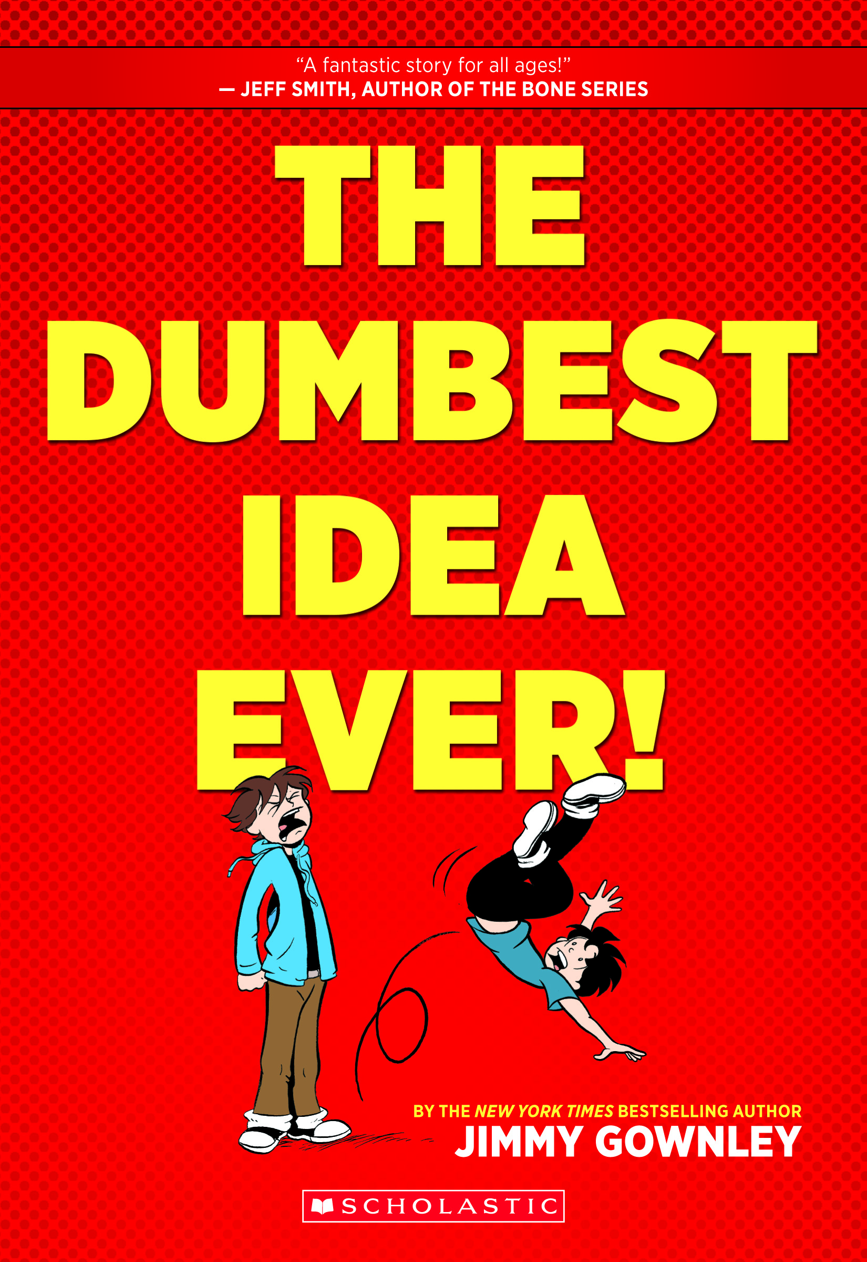 2015 The Dumbest Idea Ever! by Jimmy Gownley

Jimmy Gownley’s graphic novel memoir about the “dumb” idea that changed his life forever!
What if the dumbest idea ever turned your life upside down?
At thirteen, Jimmy was popular, at the top of his class, and the leading scorer on his basketball team. But all that changed when chicken pox forced him to miss the championship game. Things went from bad to worse when he got pneumonia and missed even more school. Before Jimmy knew it, his grades were sinking and nothing seemed to be going right.
How did Jimmy turn things around, get back on top at school, and land a date with the cutest girl in class?
Renowned comics creator Jimmy Gownley shares his adventures as he grows from an eager-to-please boy into a teenage comic book artist. This is the real-life story of how the DUMBEST idea ever became the BEST thing that ever happened to him.
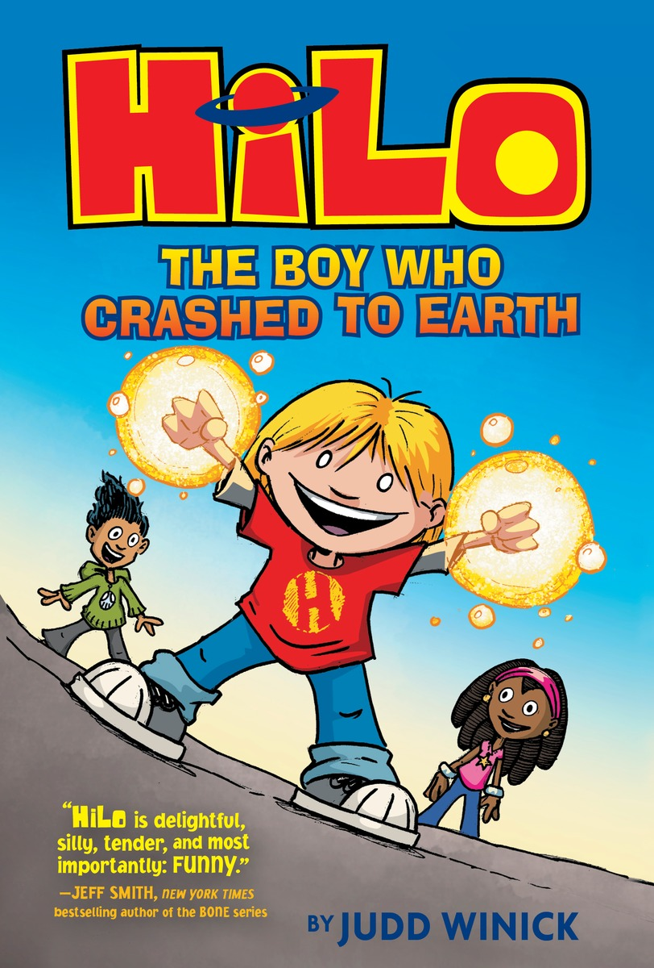 2016 Hilo Book 1: The Boy Who Crashed to Earth by Judd Winick

D.J. and his friend Gina are totally normal kids. But that was before a mysterious boy came crashing down from the sky! Hilo doesn’t know where he came from, or what he’s doing on Earth. (Or why going to school in only your underwear is a bad idea!) . . . But what if Hilo wasn’t the only thing to fall to our planet?Can the trio unlock the secrets of his past? Can Hilo survive a day at school? And are D.J. and Gina ready to save the world?

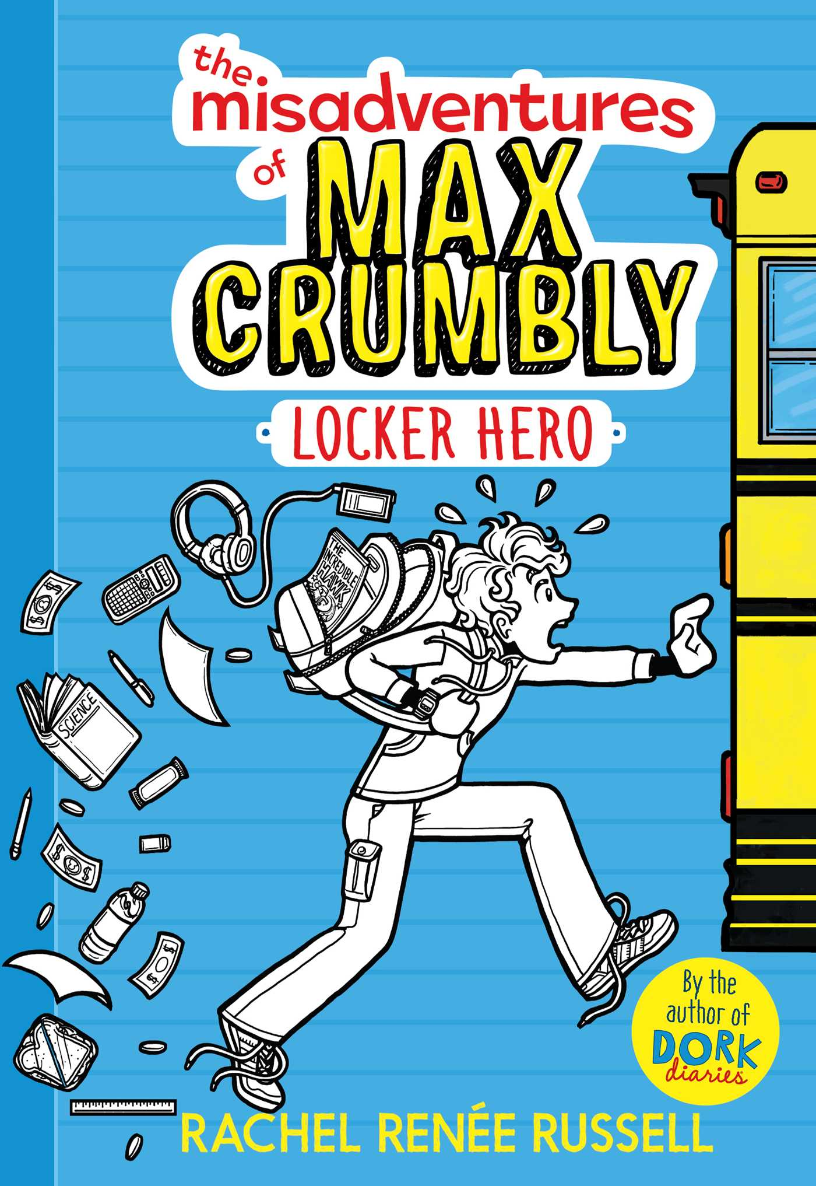 2017 The Misadventures of Max Crumbly: Locker Hero by Rachel Renée Russell

A brand-new series from #1 New York Timesbestselling Dork Diaries author Rachel Renee Russell! Introducing Max Crumbly!
Max Crumbly is about to face the scariest place he’s ever been: South Ridge Middle School.
There’s a lot that’s great about his new school, but there’s also one big problem—Doug, the school bully whose hobby is stuffing Max in his locker.
If only Max could be like the hero in his favorite comics. Unfortunately, Max’s uncanny, almost superhuman ability to smell pizza from a block away won’t exactly save any lives or foil bad guys…

