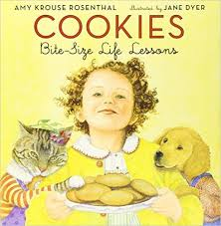
Cooperate
Patient
Proud - Modest
Respect
Trustworthy
Fair – Unfair
Compassionate
Greedy - Generous
Pessimistic - Optimistic
Polite
Honest
Courageous
Envy
Loyal
Open-minded
Regret – Content
Wise

Write a word definition using a different metaphor. For example – Lunchroom
“Your pizza looks so much better than my peanut butter sandwhich. Boy, I wish it were mine.” “Respect means letting a teacher go before you in the lunch line.” - Soccer “Pessimistic means, Oh dear, we are two goals down, we’ll never win” “Optimistic means, We’re only two goals down, we still can win.”

Questions for which you must refer to the recipes.

How much butter would I need if I wanted to make 80 Smart Cookies? ________________________

If I have a half dozen eggs, how many batches of sugar cookies can I make? ___________________

Which cookies do you think are the sweetest? ___________________________________________________

Why?__________________________________________________________________________________________________

Why would it take so much longer to make the Christmas Cookies than any of the others?

Write your own questions on the back if you have time.

