Graphic Novel Page
- Panels-squares or rectangles that contain a single scene
- Gutters-space between panels
- Dialog Balloons-contain talking between/among characters
- Thought Balloons-contain a character's thoughts
- Captions-contain information about a scene or character
- Sound Effects-visual sound clues i.e.. Wonk! Pow!
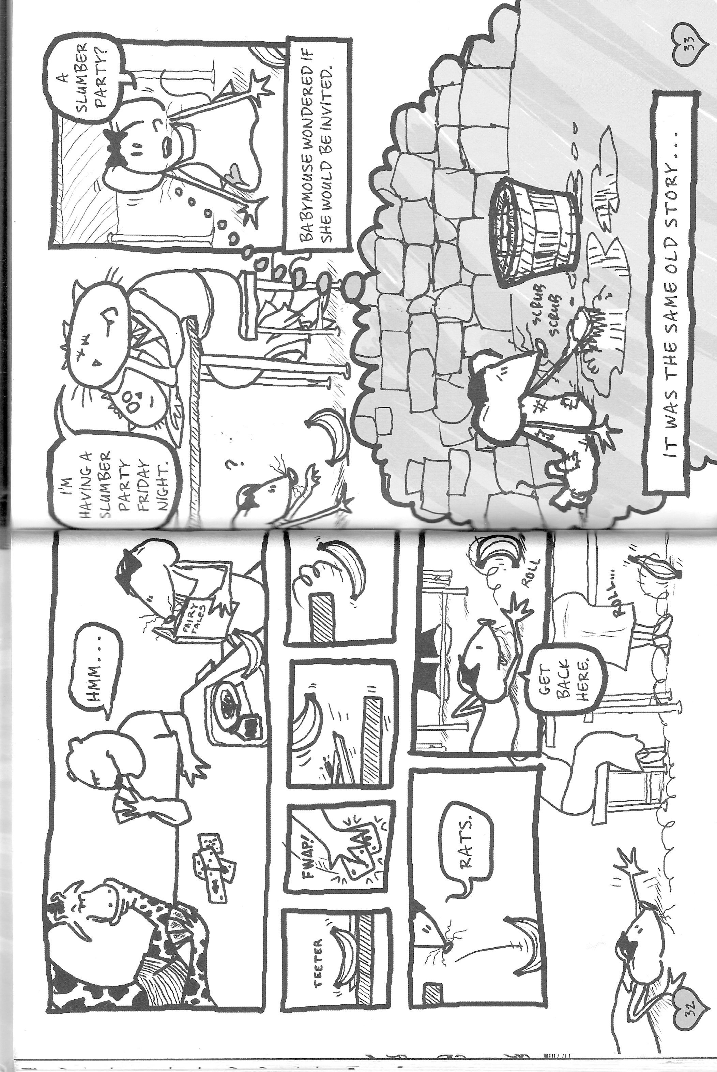
Holm, JenniferL. and Matthew Holm (2005) Babymouse: Queen of the World! New York: Random House

