If da Vinci painted a DINOSAUR written by Amy Newbold pictures by Greg Newbold
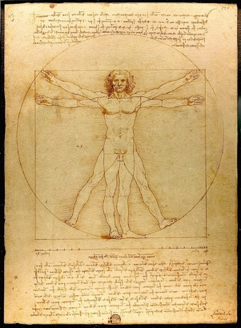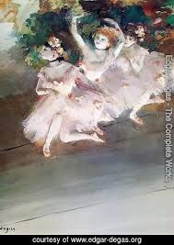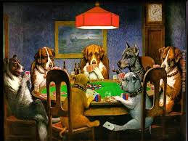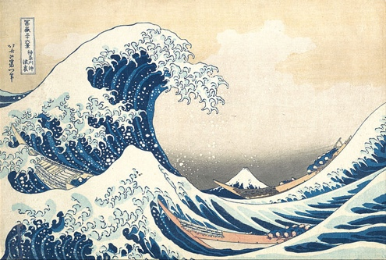
dajVinci Degas Coolidge Katsushika Hokusai

If da Vinci painted a DINOSAUR written by Amy Newbold pictures by Greg Newbold
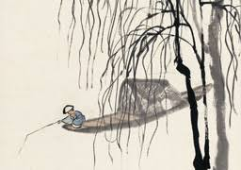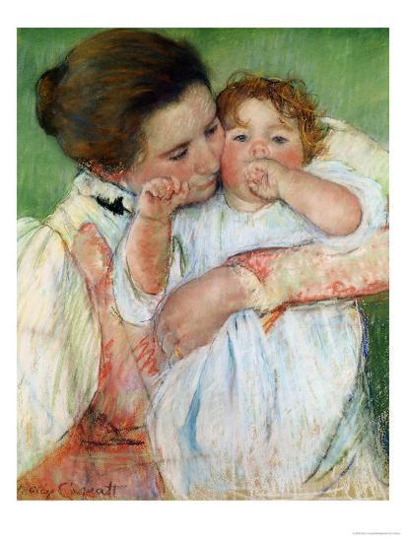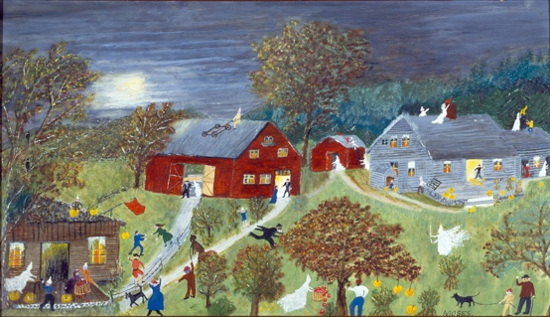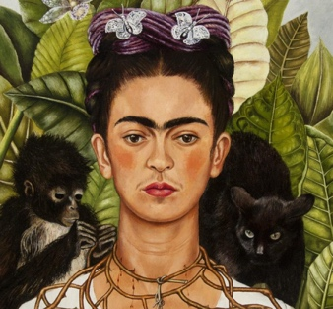
Qi Baishi Mary Cassat Grandma Moses Frida Kahlo

If da Vinci painted a DINOSAUR written by Amy Newbold pictures by Greg Newbold
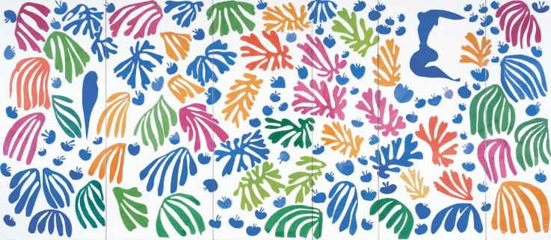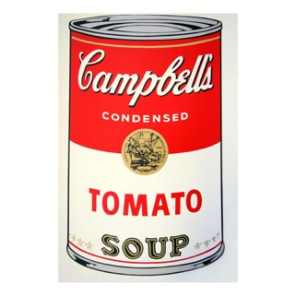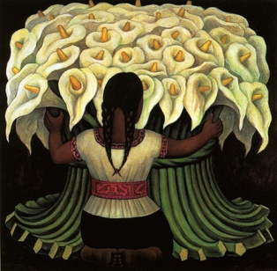
Henri Matisse Andy Warhol Diego Rivera

If da Vinci painted a DINOSAUR written by Amy Newbold pictures by Greg Newbold

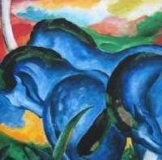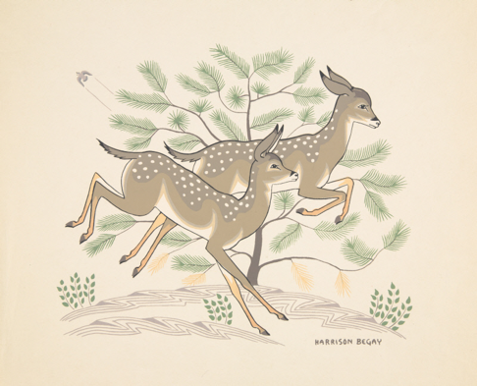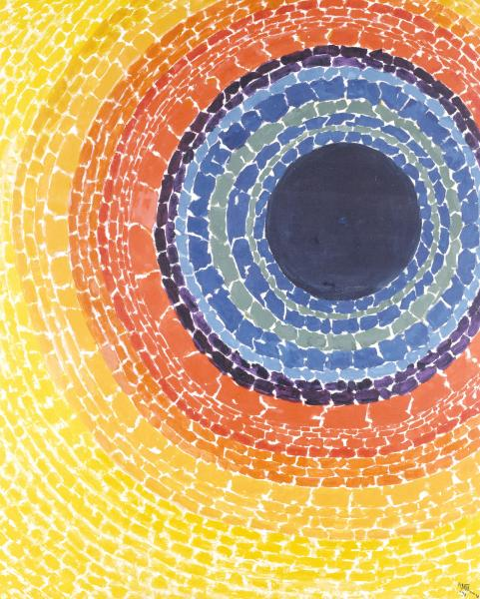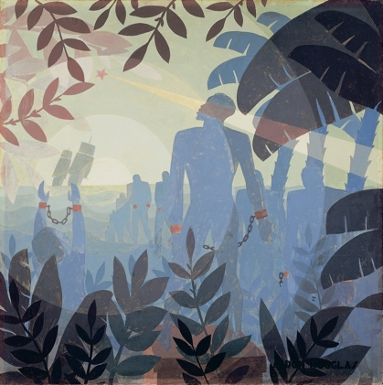
Franz Marc Harrison Begay Alma Thomas Aaron Douglas

