Michael Hall - graphic artist turned children's book author - Minnesota http://www.Michaelhallstudio.com
Graphic design -

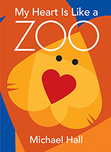
Simile
Metaphor
Use Heart shapes to create an animal.

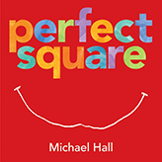
Day of the week
Use Origami Paper to create a place

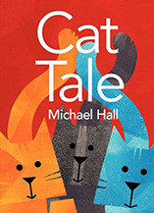
Homonym
Homophone
Use Origami Paper to create a cat
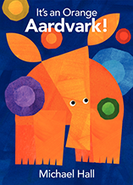

Colors of the Rainbow
Dye cut holes punched to create a sequence of pictures.

