Middle Grade Books written from a Dog’s point of view.
The Dog is the narrator
Katherine Applegate
Katherine Apploegate Bruce Cameron – A Dog’s Purpose books and then movies
And Gennifer Chaodenko
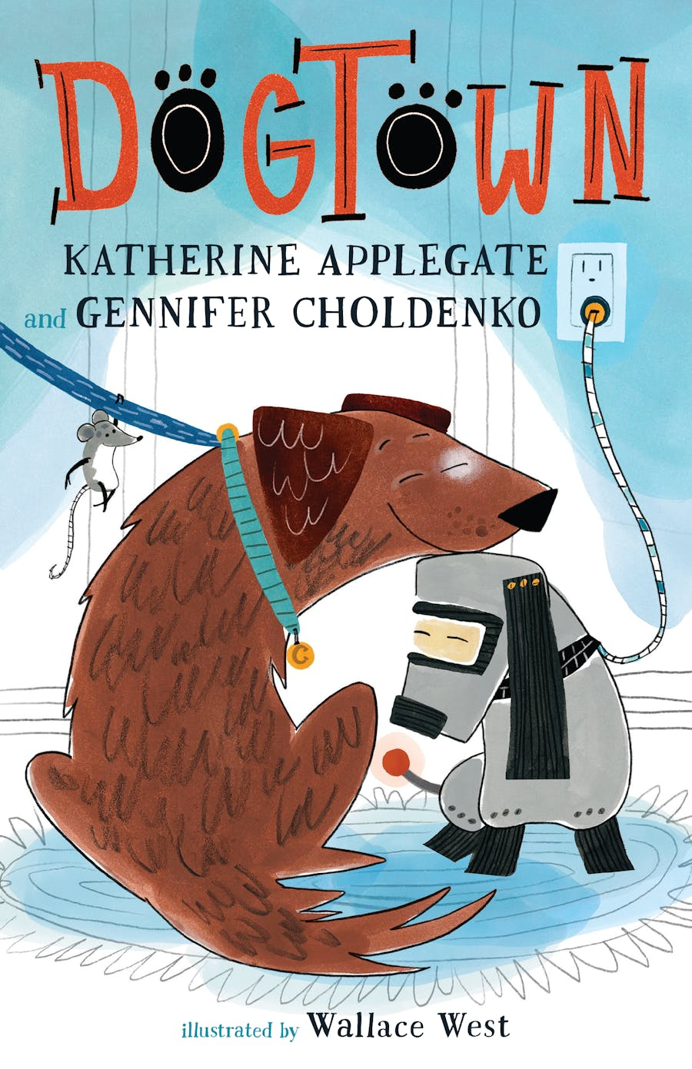

Ann M. Martin Garth Stein
