Picture Book Month Mrs. Murphy and Ms. Conrad’s Classes 2016

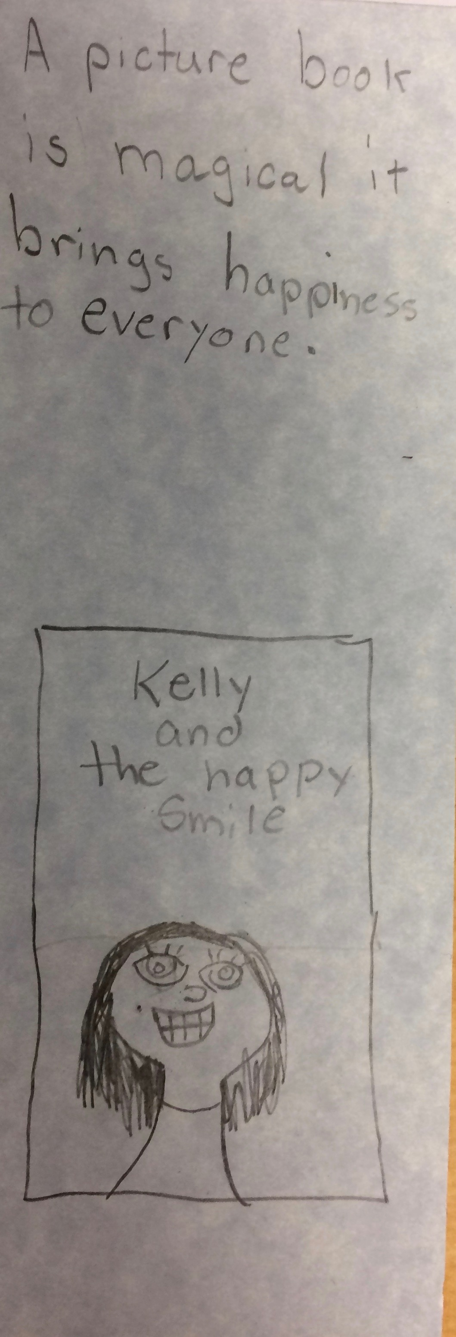A picture book is magical. It brings happiness to everyone. Kelly and the Happy Smile (does not need to be underlined on the cover of the book.

A picture book is a gateway to your imagination.
A picture book is a key to life.
A picture book is a train to a whole other world. (sorry picture was out of focus)
A picture book is that something you can let your imagination run wild. It takes you to another world. It’s something that lets you buzz around.
A picture book is just to start your imagination.
A picture book is like my vision coming to life.
A picture book is a spark of messages.
A picture book is another world. A picture book is your mind will go crazy with your imagination.
Picture books are a mobile gallery. Art Gallery
A picture book is important because kids and people can read picture books anytime or anywhere. OMG! Look a dinosaur! Power Ranger go!
A picture book is a key, spark, and pathway to bring out the inner you of imagination!
A picture book is a stairway to an imagination. imagination
A picture book is an inspiration to us all.
I think a picture book is a gateway to adventure and inspiration.
A picture book is something that everyone loves.
- They inspire me a lot
- Sometimes they make me laugh
- When I’m bored they are useful
- They have information that you want to know
A picture book is a gateway to imagination.
A picture book is a stairway to imagination.
A picture book is a stairway to an imagination.
A picture book is an adventure to other places.
A picture book is …. a book to inspire little kids that can’t read.
A picture book is where kids learn to grow up because they have good imaginations.
A picture book is a key to imagination to a different world. another world
A picturebook is the key to the doorway to imagination.
A picture book is (a or the) door to (an or the) inspirational colorful world.

